sean singleton
MTU R00221306
INS Autumn Assignment

Contents
Video Link 3
Introduction 3
Network Setup: 4
Ruby on Rails 5
Service Description 5
Installation Steps and configurations 5
Verification 10
DNS Server (BIND) 11
Service Description 11
Installation Steps 11
Configuration and verification: 12
Email Server & POP/IMAP Server 17
Service Description 17
Installation Steps 17
Verification 26
Print Server (CUPS/Bonjour) 31
Service Description 31
Installation Steps 31
Configuration 31
Testing and Verification 33
SSH Server 42
Service Description 42
Installation Steps 43
Configuration 43
Testing and Verification 46
DHCP Server 50
Service Description 50
Installation Steps 50
Configuration 50
Testing and Verification 53
Network Management System 54
Service Description 54
Installation Steps 54
Configuration 57
Testing and Verification 62
Customisation & Integration of Solution 67
Final Report - Summary & Conclusion 69
Summary 69
Conclusion 69
References 70

Video Link

https://youtu.be/z7qp6FqL7b0

Introduction
In today's digital era, businesses depend on reliable Internet and Network Services to ensure seamless operations. As a system administrator at "singleton-IT," your task is to configure and secure essential services on an Ubuntu Server OS. This project involves setting up and verifying the functionality of the following services:
- Ruby on Rails: A web application framework for developing dynamic websites and applications.
- DNS Server (BIND): Translates domain names into IP addresses.
- Email Server & POP/IMAP Server: Manages and facilitates email communication.
- Print Server (CUPS/Bonjour): Enables network printing.
- SSH Server: Provides secure remote access to the server.
- DHCP Server: Dynamically assigns IP addresses on the network.
- Network Management System: Monitors server and desktop environments.
This report includes detailed installation instructions, configuration settings, and verification methods for each service. Additionally, it highlights customizations and integrations that enhance the solution, followed by a summary and conclusion reflecting on project outcomes.
By completing this project, you will gain practical experience in setting up and managing critical network services, reinforcing your technical skills, and preparing you for real-world IT scenarios.

Network Setup:

For static IP follow the below netplan config for both vms and have vms set to host only this allows for the server and desktop to communicate with each other.

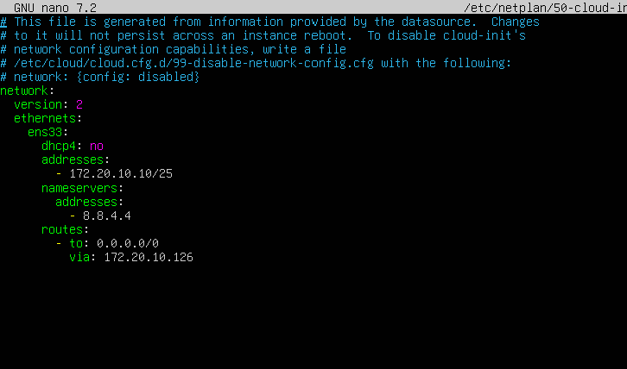

When Installing on server and ubunto you need internet connection switch vm’s to bridged network connection and use this netplan config file

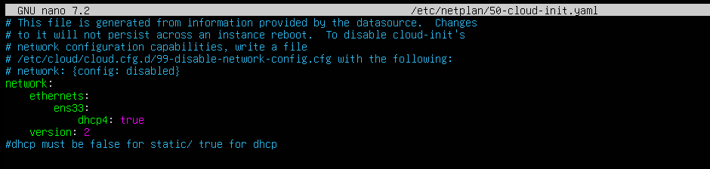

Ruby on Rails

Service Description
Ruby on Rails, often referred to as Rails, is a popular web application framework written in Ruby that follows the Model-View-Controller (MVC) architecture. It emphasizes "Convention over Configuration," which simplifies the development process by providing sensible defaults, and "Don't Repeat Yourself" (DRY) principles to minimize code duplication. Rails includes an Object-Relational Mapping (ORM) layer called Active Record, which facilitates easy database interactions, and it supports the creation of RESTful applications with clean, resource-based routes. With built-in security features and a vast ecosystem of plugins, Rails is well-suited for rapid development of scalable and maintainable web applications.

Installation Steps and configurations
- Install Dependencies:
  - sudo apt-get update
  - sudo apt-get install git-core zlib1g-dev build-essential libssl-dev
libreadline-dev libyaml-dev libsqlite3-dev sqlite3 libxml2-dev libxslt1-dev
libcurl4-openssl-dev software-properties-common libffi-dev
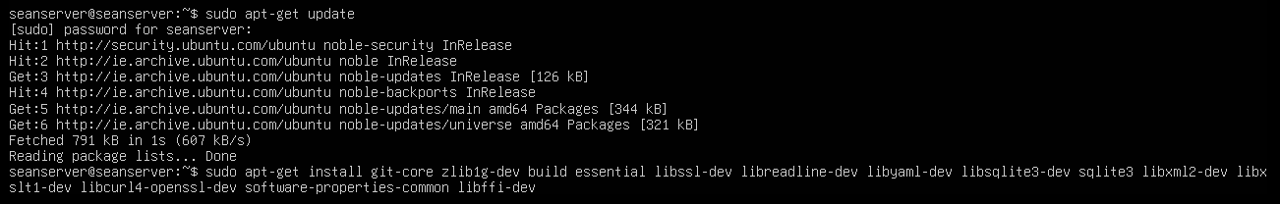
Here you get asked if you want to continue with the download just type “y” and it will download.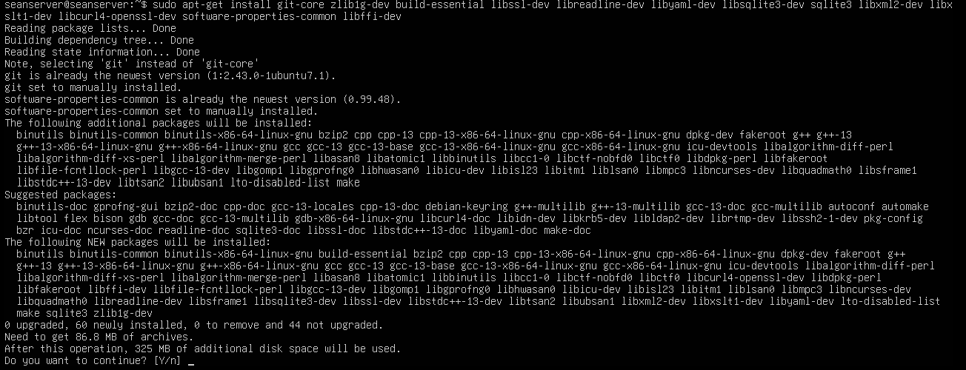
- Ruby install with ASDF manager:
  - 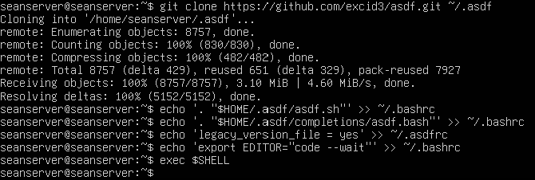
- Install plugins for ASDF and for the language we will use node.js and ruby for the front end java script
  - 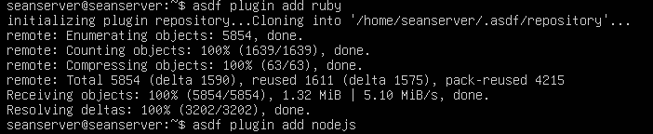
- Ruby Install version 3.3.3
  - 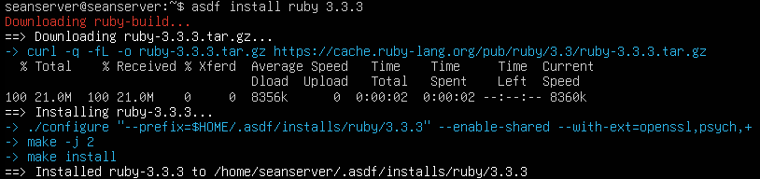
  - Next commands we will use are “asdf global ruby 3.3.3” sets Ruby version 3.3.3 as the global default version on the system. Then we use “gem update –system” to update the rubygems to the latest version and finally we confirm the ruby version matches the one wee just installed.
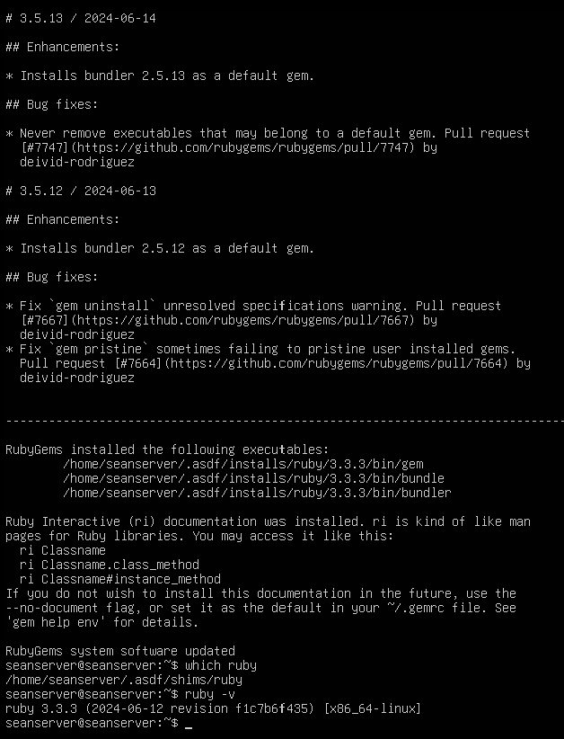
- Install Node.js
  - 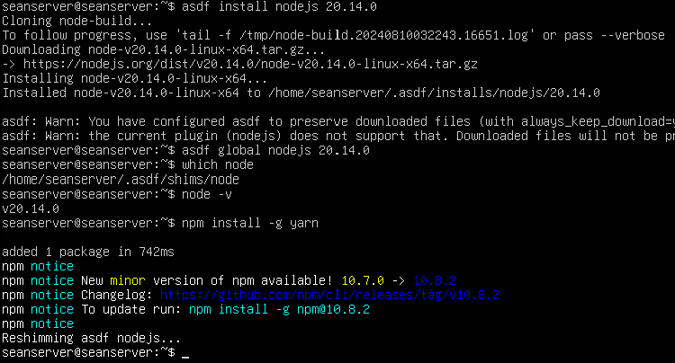
- Configuring Git
  - 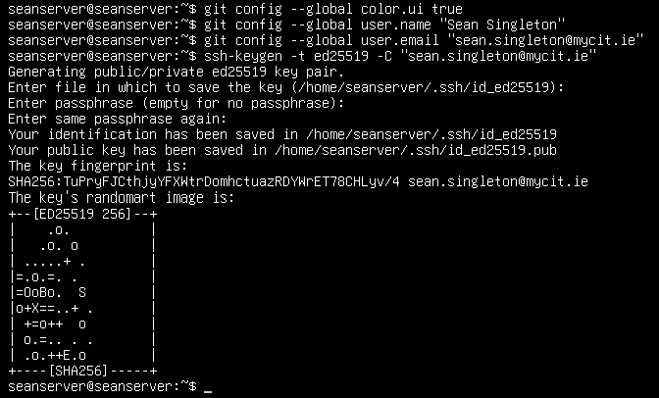
  - 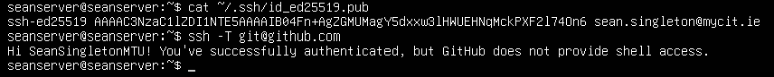
- Installing Rails:
  - Using the command “gem install rails -v 7.2.0.beta2” we install the latest version of rails and to verify it we use the command rails -v and as you can see here we have the right version
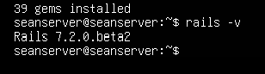
- Setting up PostgreSQL
  - Using the command “sudo apt install postgresql libpq-dev” we install PostgreSQL, you will also be asked to continue and just type in “y” and then enter.
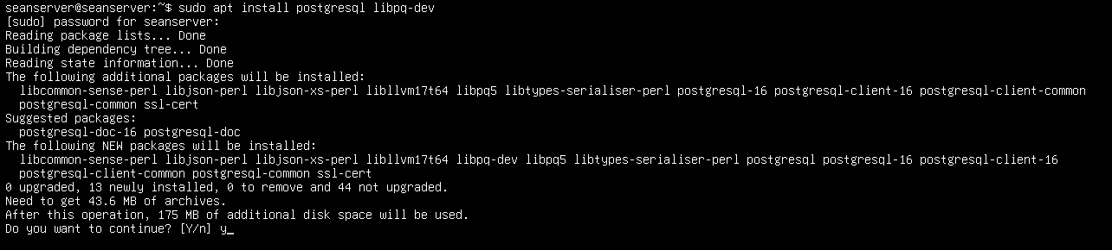

  - We need to now create a user which in this case will be for myself “sean” so we use the command “sudo -u postgres createuser sean -s”
  - To set a password we use the command “sudo -u postgres psql” and just for this instance I will use “sean” here is a screenshot of this, to exit this then just use the command “\q” or there is the “\help” with all the commands.
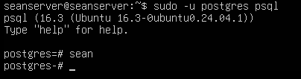
- Create Rails
  - Using the command “rails new myapp -d postgresql” and this will create the rails application as seen here as we can now cd into our new application directory using “cd myapp” and “ls” to see all our files for our application inside.
  - Next to make sure we use this command while in our myapp directory “nano config/database.yml” and verify that our username and password are correct.
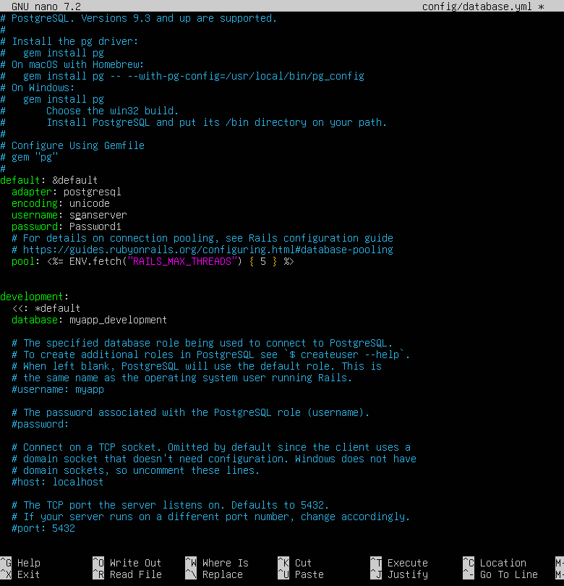
  - The final commands we will use here is “rake db:create” this successfully creates the database and then once that is done to start our ruby on rails application we use the command “rails server -b 0.0.0.0” as we see in the second screenshot below.
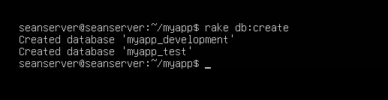
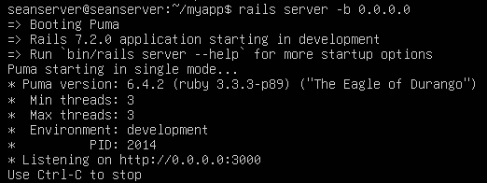
  - Now onto our desktop to verify that our rails application is running and working.

Verification
- To verify this we must change both of the virtual machines to host only as in this screenshot
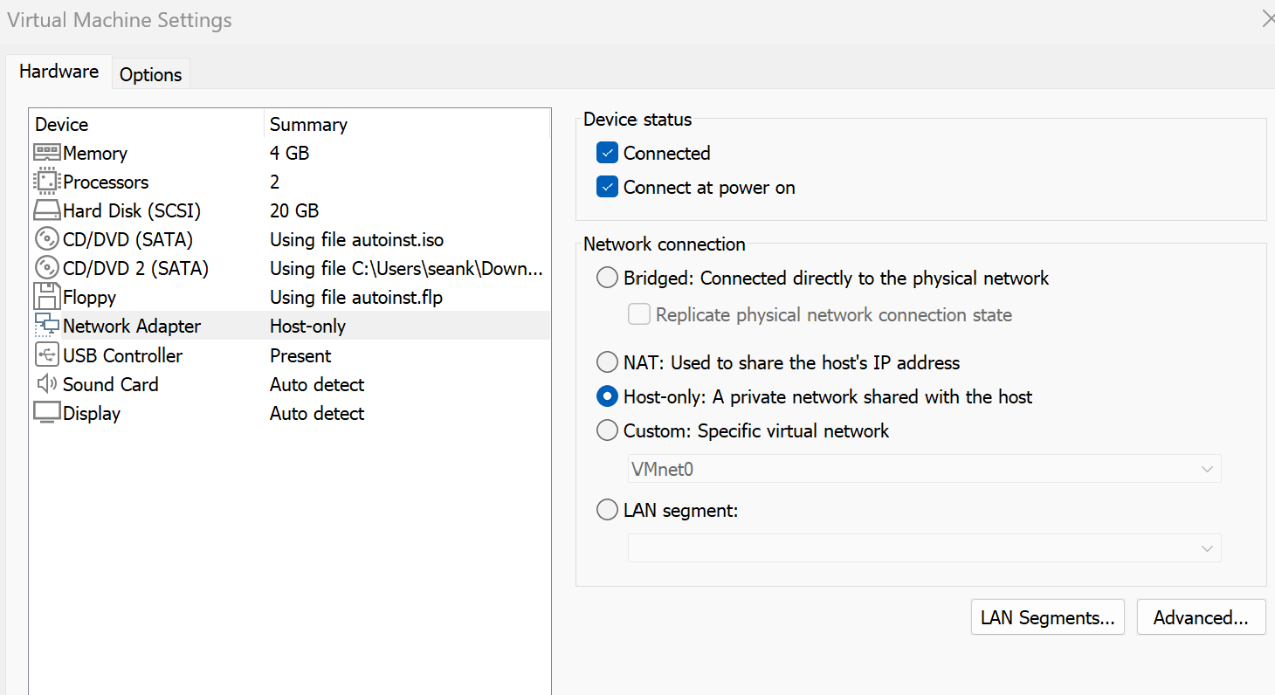

- Next we make sure the static ips are set by editing our netplan through each vm and the command to edit them is this “sudo nano /etc/netplan/50-cloud-init.yaml” and having them configured as the static ip settings from the setup section at the start of this document, also by using the command “ip a” we verify the static ip is set on each here is a screenshot from both vms showing that the correct ips are setup with the right ens which here is “ens33”
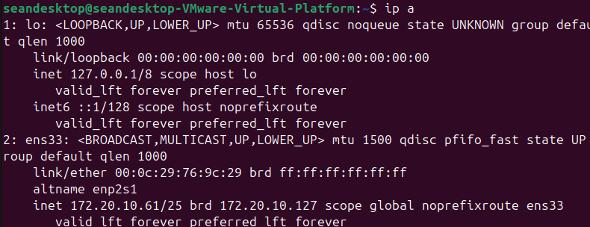 desktop
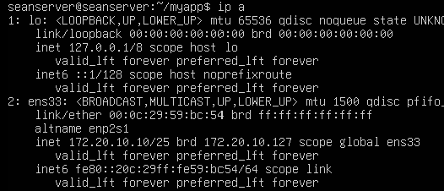 server
- Now we turn to our Desktop vm and we open up firefox and in the url we put in the ip address of our server vm http://172.20.10.10:3000 and once this is entered you should see the default Ruby on Rails welcome page. This indicates that the Rails server is running and accessible over the network. As seen in this screenshot
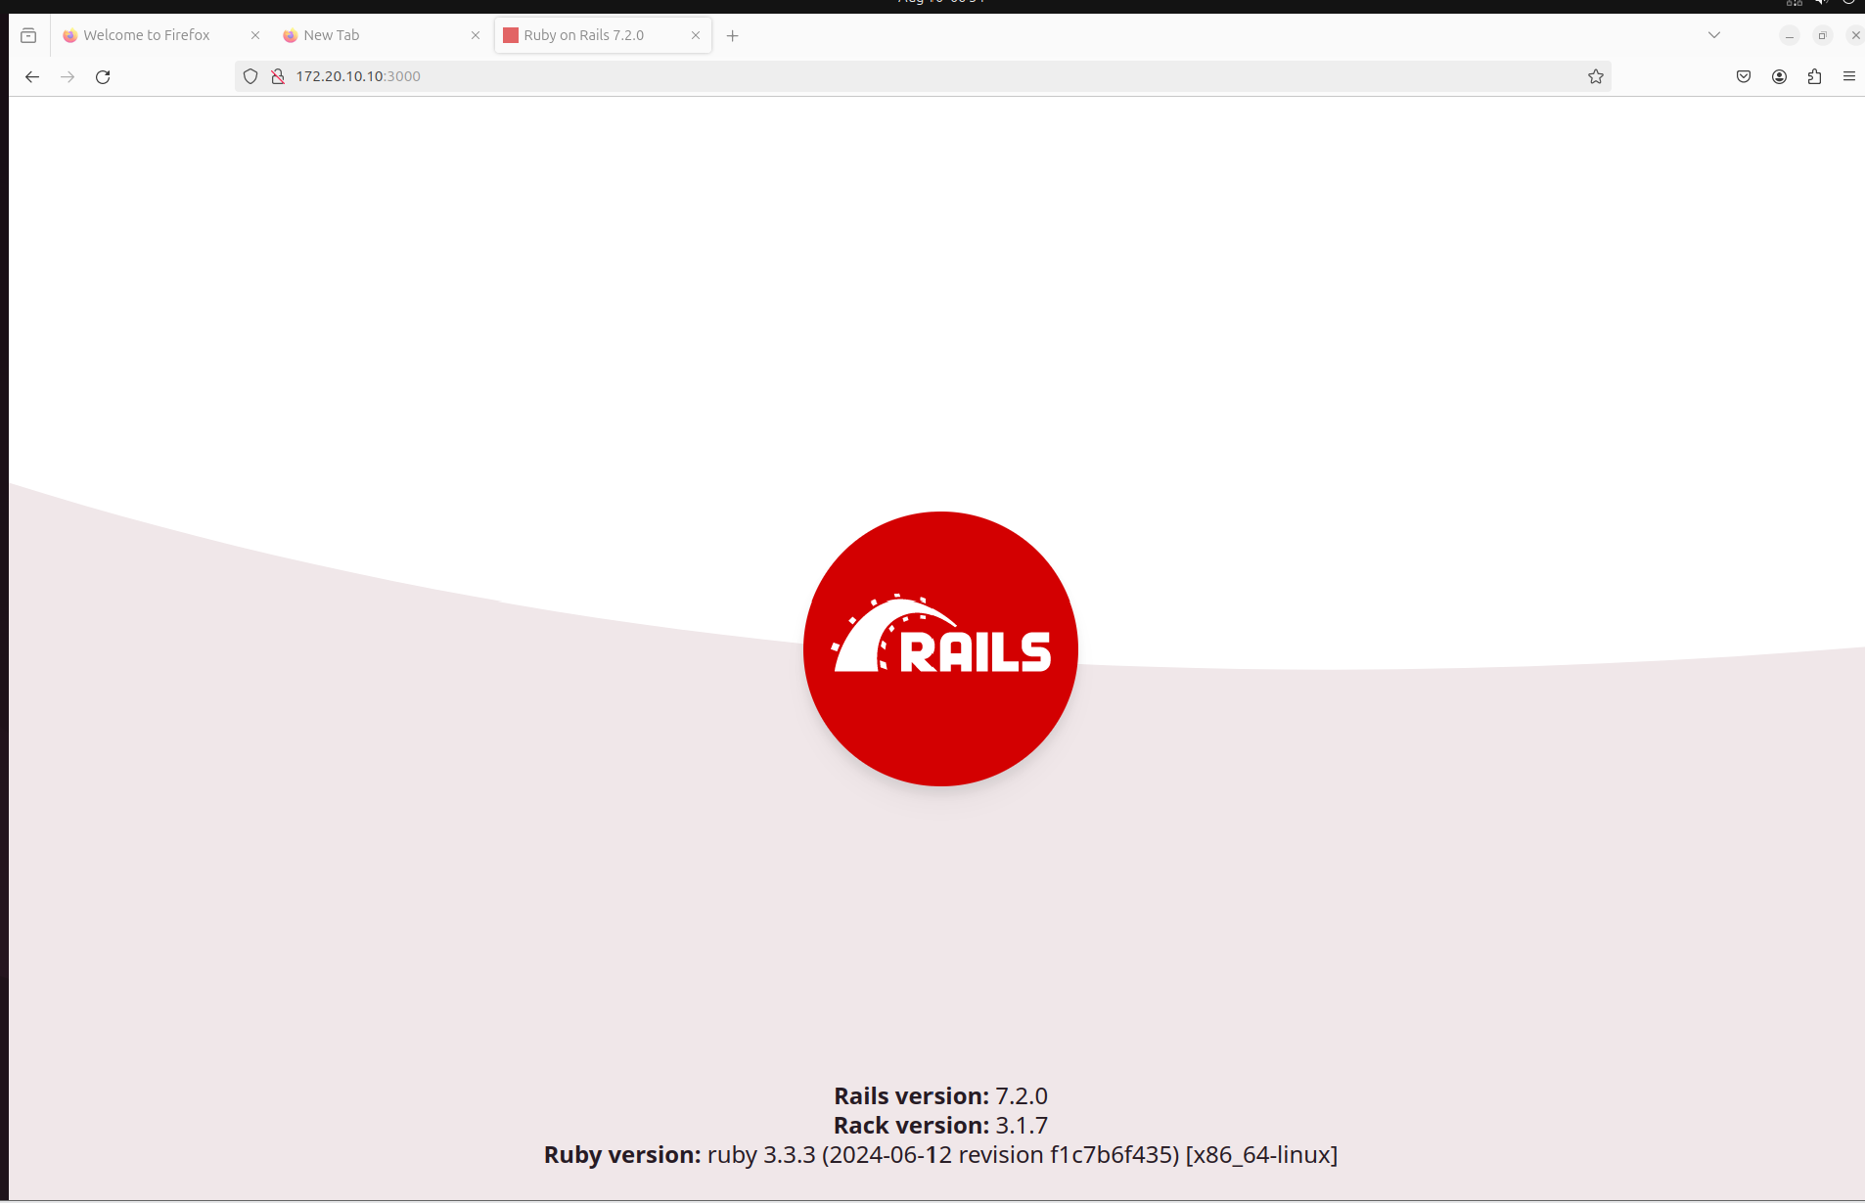
We can verify many things here our rails version from the steps we used 7.2.0 our ruby version 3.3.3and our server vm ip in the url showing we successfully have installed ruby on rails through our server.

DNS Server (BIND)

Service Description
BIND (Berkeley Internet Name Domain) is one of the most widely used Domain Name System (DNS) server software. It translates human-readable domain names, like singleton-IT.com, into IP addresses that computers use to communicate with each other over a network. BIND is highly configurable and supports various DNS features, including zone transfers, dynamic updates, and caching. It plays a critical role in managing domain names for networks, allowing users to access services by name rather than having to remember numeric IP addresses.

Installation Steps

- firstly we must revert our server vm back to dhcp so we can be connected to the network so we can install and download what we need to for BIND, so to do this
- secondly, we use the command to update the package list “sudo apt update”
- Then we use the command to install BIND9 and this command is “sudo apt install bind9 bind9utils bind9-doc” once you press enter you will be asked if you wish to continue in the download and here just type “y” and enter to complete this download.
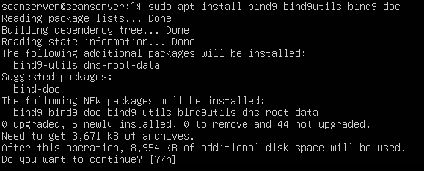

Configuration and verification:

- Configure Bind:
  - Set up the DNS zone:
    - For this we must edit the named.conf.local file this is where you define the DNS zones which BIND will manage. The command for this is “sudo nano /etc/bind/named.conf.local” here we will make changes to the file.
    - Here The zone configuration in BIND tells the DNS server that it is authoritative for a specific domain which is singleton-IT.com here. The server will use the zone file located at /etc/bind/db.your_surname-IT.com to resolve DNS queries for this domain, providing the necessary IP addresses and other DNS records as defined in that file.
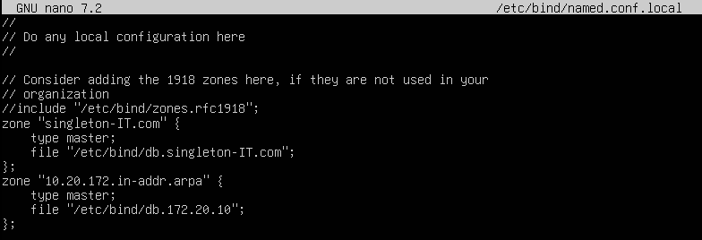
This configuration tells BIND9 that it will be the primary (master) DNS server for the domain singleton-IT.com and that the zone data (DNS records) for this domain will be stored in the file /etc/bind/db.singleton-IT.com.
The reverse zone allows DNS to map IP addresses back to domain names (reverse lookup). Here, it corresponds to the 172.20.10.0/25 subnet, which covers the network.
  - Create the Zone file:
    - First off we copy the default db.local file for our domain and the command for this is “sudo cp /etc/bind/db.local /etc/bind/db.your_surname-IT.com”
    - Now we edit our new zone file and the command to do this is “sudo nano /etc/bind/db.singleton-IT.com” with your surname put in and now we will modify the zone file to reflect our domain and IP address here is a screenshot of the configuration of our new zone file.
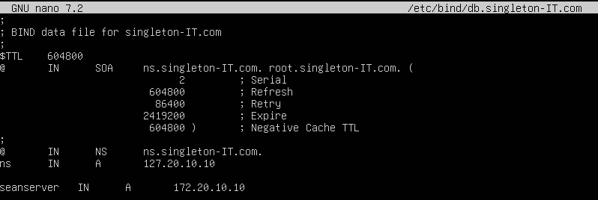
      - This file sets up the DNS records for your domain:
      - SOA (Start of Authority) defines the primary name server (ns.singleton-IT.com) and the email address of the domain administrator (root@singleton-IT.com).
      - NS record indicates that ns.singleton-IT.com is the name server for the domain.
      - A records map the hostname seanserver.singleton-IT.com to the IP address 172.20.10.10.
    - Now we create the reverse zone file and we will also edit it with the following commands for creating it we use the following “sudo cp /etc/bind/db.127 /etc/bind/db.172.20.10” and
“sudo nano /etc/bind/db.172.20.10” here you copy the reverse DNS template (db.127) to create a new reverse zone file for your network and then edit it to map IP addresses back to hostnames.
Now the editing of our new reverse zone file.
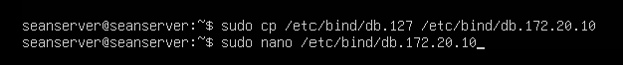
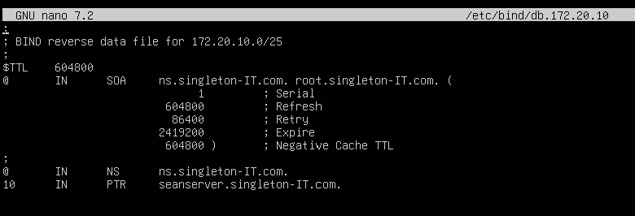

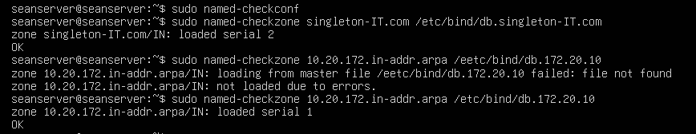

  - Test BIND Configuration:
    - We check the config file for bind for any errors with the command “sudo named-checkconf” we also can verify the zone file for any syntax errors with this command “sudo named-checkzone your_surname-IT.com /etc/bind/db.your_surname-IT.com” and finally restart BIND to apply all the configurations. All the commands are shown in the screenshot below.
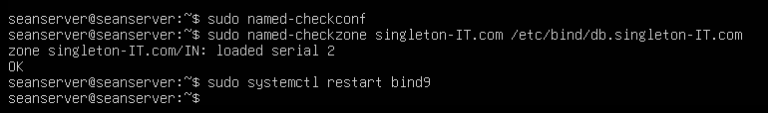
  - Configure desktop VM to use DNS server from ubunto server:
    - For this we must revert to host-only and to static IP as shown at start in setup with static IP setup.
Testing reverse DNS Resolution: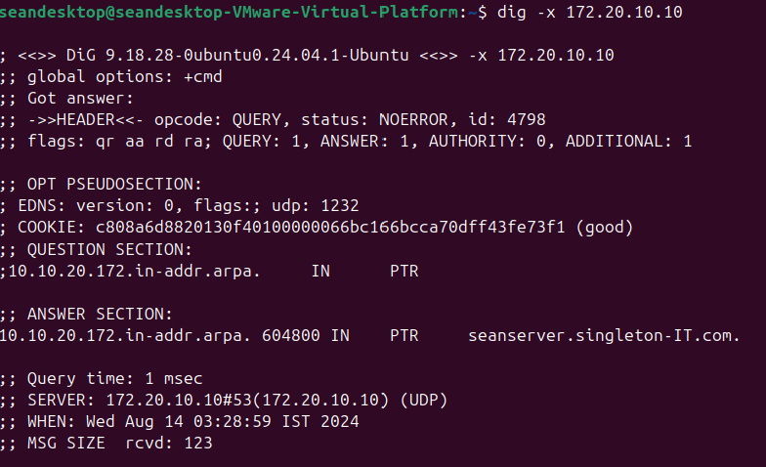
Testing Forward DNS Resolution:
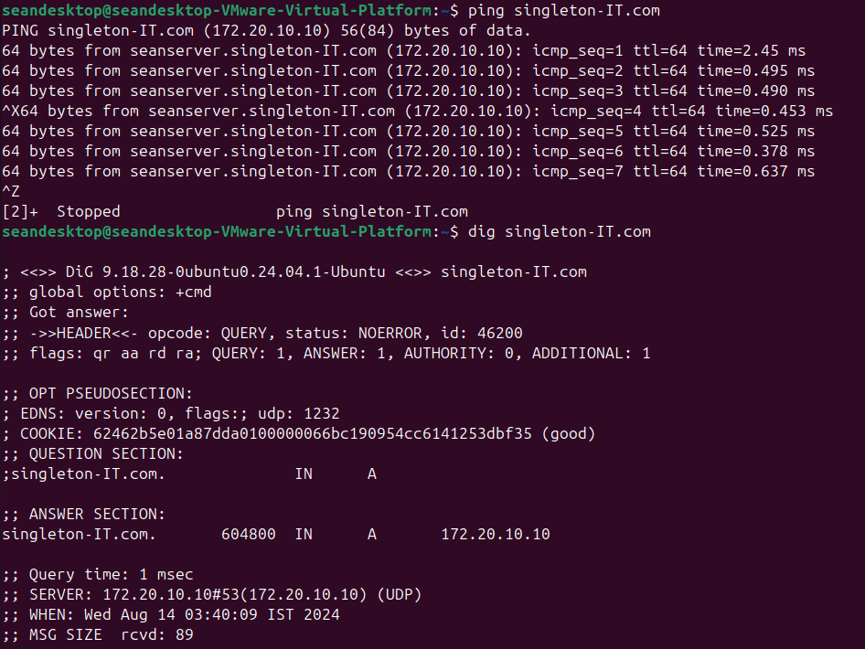
    - 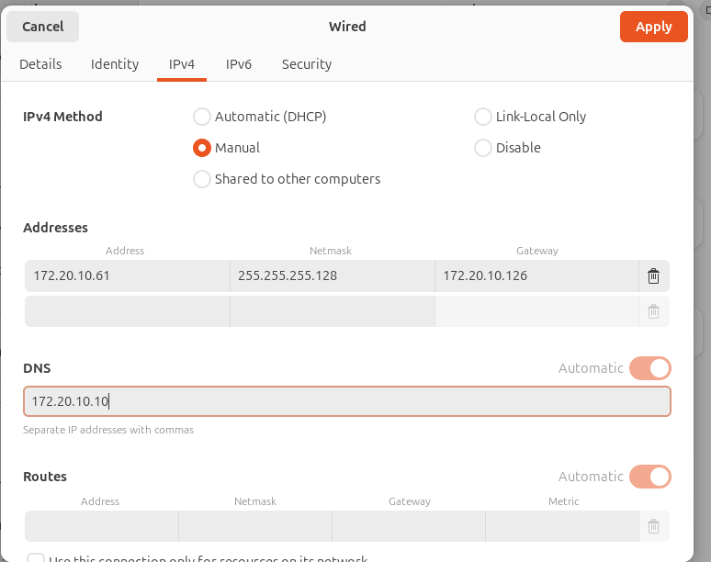
    - 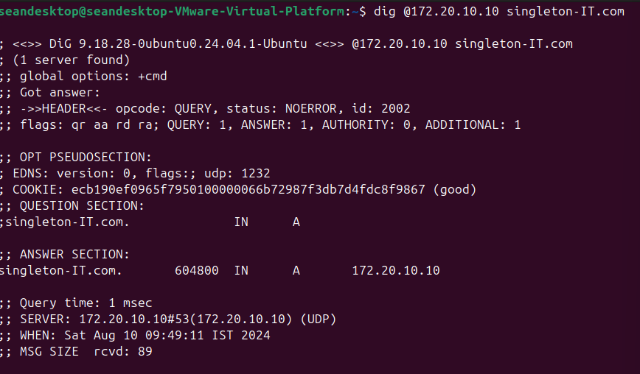

Email Server & POP/IMAP Server

Service Description
The Postfix email server manages the sending and receiving of emails within the singleton-IT.com domain. It handles the routing of outgoing emails to external recipients and delivers incoming emails to users' mailboxes on the server. Postfix works in tandem with the Dovecot service to ensure that emails are securely stored and readily accessible, supporting both internal and external communication needs.
The Dovecot service provides IMAP and POP3 access to emails stored on the server. It allows users to retrieve and manage their emails from various devices and clients while ensuring secure authentication and efficient email storage. Dovecot ensures that users can access their mailboxes seamlessly, whether they are connecting via IMAP for synchronized email access across devices or POP3 for local email retrieval.

Installation Steps
- Install Postfix and Dovecot:
  - Step 1: Install the Required Package with the commands “sudo apt update” and then you will have to type “y” to continue the update then we use the command “sudo apt install postfix dovecot-core dovecot-imapd dovecot-pop3d”
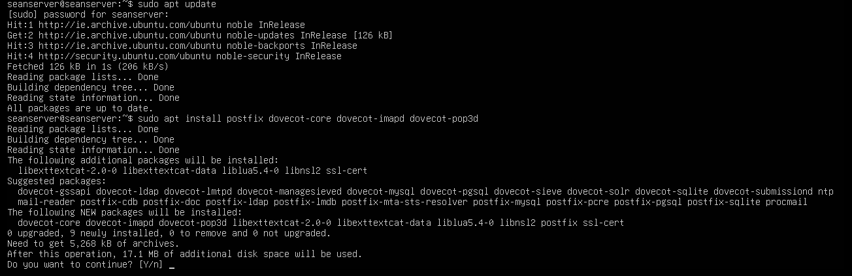
  - Once this is done you now get brought to a package configuration here choose “internet site” and then hit “ok” then in the next part change the name to “singleton-IT.com” or what your system mail name will be.
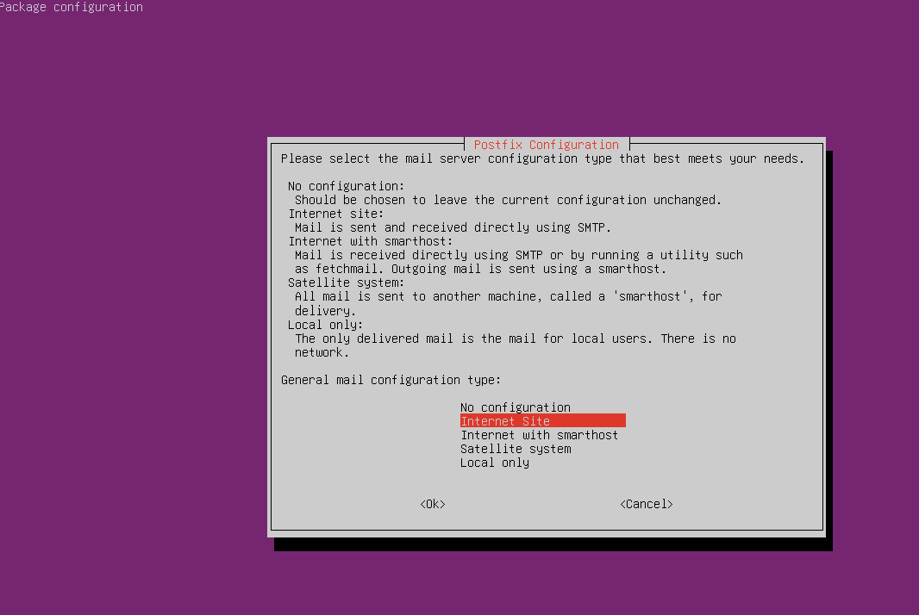
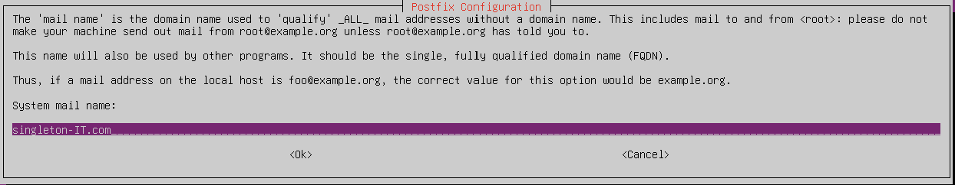

- Configure Postfix:
  - Basic Postfix Configuration:
    - For this we use the command “sudo dpkg-reconfigure postfix” what does this does is during the reconfiguration of Postfix, you will be prompted to answer several configuration questions that determine how Postfix will behave. It goes more in depth compares to last package config.
  - Configuration Prompts and Responses:
    - General type of mail configuration:
      - Select "Internet Site". This configures Postfix to send and receive email directly using the Internet.
    - System mail name:
      - Enter singleton-IT.com. This sets the default domain name for your email server, which will be appended to any outgoing email addresses if they don’t already include a domain.
    - Root and postmaster mail recipient:
      - Accept the default or set it to an appropriate user. This setting determines who will receive system-generated emails (like error messages) addressed to root or postmaster. Here we leave it blank.
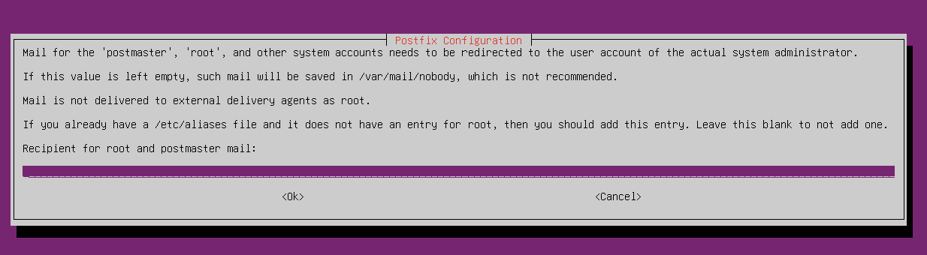
    - Other destinations to accept mail for:
      - Ensure it includes singleton-IT.com. This defines the domains for which your Postfix server will accept incoming emails. It should include your domain, singleton-IT.com, and any additional domains your server will manage, as you can see the ones used below.
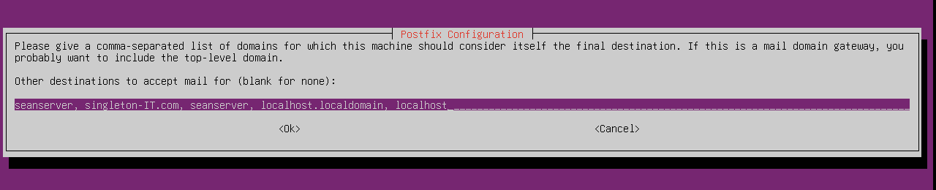
    - Force synchronous updates on mail queue:
      - Select "No". Synchronous updates ensure that emails are written to disk immediately, which can be more reliable but slower. Selecting "No" allows faster performance by letting Postfix use buffered writes.
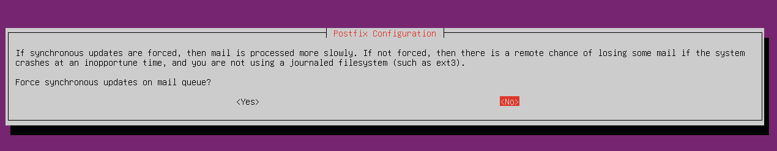
    - Local networks:
      - Enter 127.0.0.0/8 [::1]/128 172.20.10.0/25. This specifies the networks that are allowed to relay mail through your server. It includes the loopback network (for local communication) and your specific local network, here we just added our own local network.
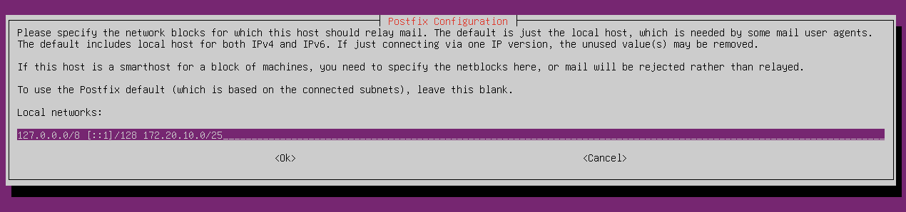
    - Mailbox size limit:
      - Set this as appropriate (0 for unlimited). This specifies the maximum size of a user’s mailbox. Setting it to 0 means there is no limit.
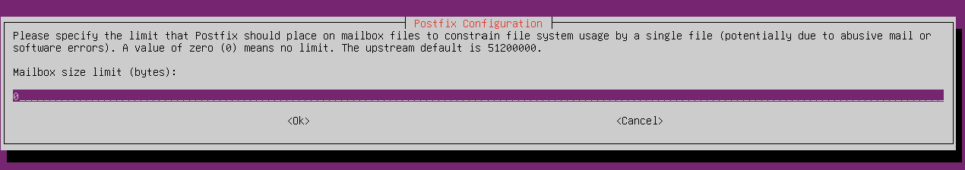
    - Local address extension character:
      - Accept the default (+). This allows users to receive emails addressed to username+extension@domain.com, which can be useful for filtering or categorizing emails.
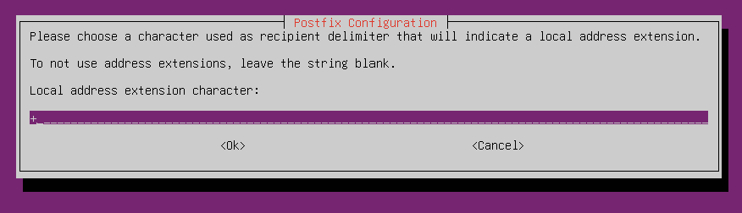
    - Internet protocols to use:
      - Select "all" (both IPv4 and IPv6). This configures Postfix to support both IPv4 and IPv6 addresses for sending and receiving emails, then just click ok.
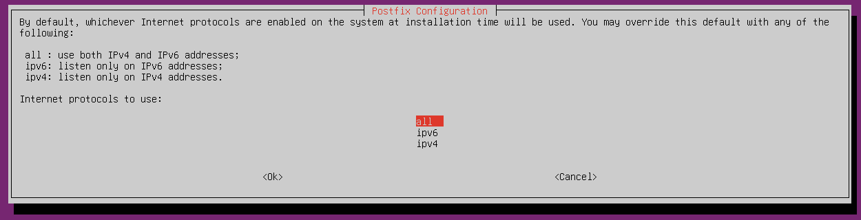
  - Manual Postfix Configuration:
    - Edit the Postfix configuration file:
      - Use the command “sudo nano /etc/postfix/main.cf” to enter this config file
    - Key settings to verify/update:
      - myhostname = seanserver
      - myorigin = /etc/mailname
      - mydestination = seanserver, singleton-IT.com, seanserver, localhost.localdomain, localhost
      - relayhost =
      - home_mailbox = Maildir/
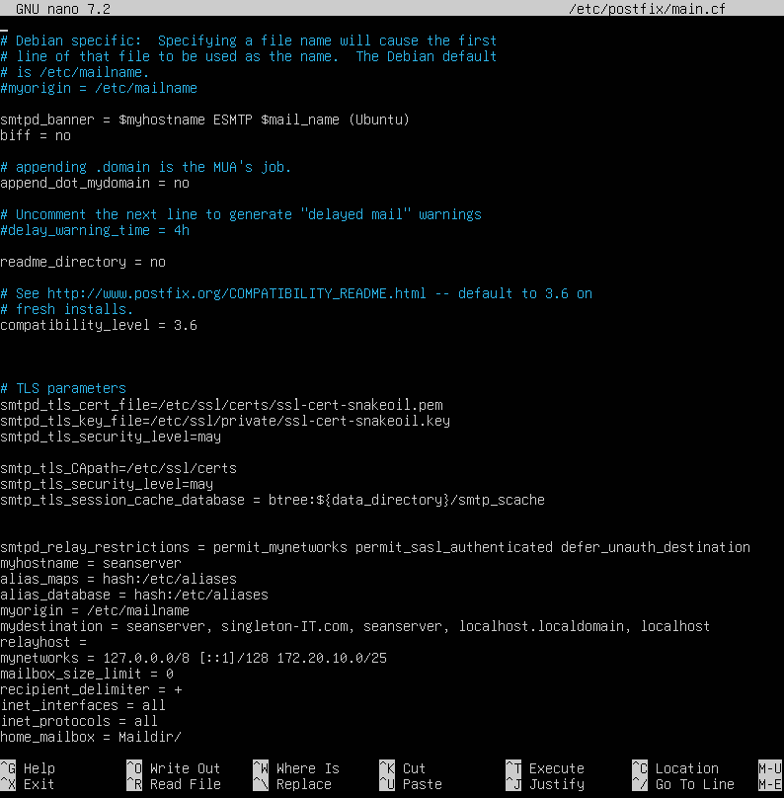
    - Explanation for each of these:
      - myhostname: Sets the hostname of your email server. It should match the name configured in your DNS for the mail server.
      - myorigin: Sets the origin domain for emails sent from your server. The /etc/mailname file typically contains your domain name.
      - mydestination: Lists the domains that your Postfix server will handle mail for, including your mail server's hostname, your domain, and localhost for local delivery.
      - relayhost: Specifies if Postfix should send outgoing mail through another SMTP server. Leaving this blank means Postfix will send mail directly
      - home_mailbox = Maildir/: Configures Postfix to deliver incoming mail to a Maildir directory in each user’s home directory. The Maildir format is a widely used format for storing emails that is more reliable and easier to manage than the older mbox format.
- Configure Dovecot:
  - Dovecot Configuration
    - Edit the Dovecot configuration file:
      - Use the command “sudo nano /etc/dovecot/dovecot.conf” to enter the dovecot config file the bottom line shows they are both enabled both protocols and mail location.
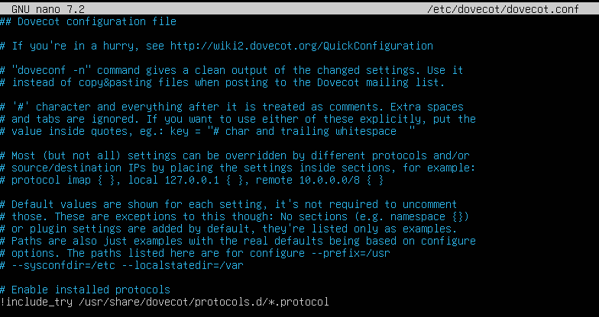
    - Ensure the following settings are included:
      - protocols = imap pop3
      - mail_location = maildir:~/Maildir
    - Explanation for each of these:
      - protocols: Specifies that Dovecot will support both IMAP and POP3, allowing users to choose either protocol for accessing their emails. IMAP is generally preferred because it allows users to view their emails on multiple devices, while POP3 downloads emails to a single device.
      - mail_location: Configures where Dovecot will look for user emails. The maildir:~/Maildir setting ensures that Dovecot retrieves emails from the Maildir/ directory in each user’s home directory.
  - Additional Dovecot Configuration
    - Edit the authentication configuration:
      - sudo nano /etc/dovecot/conf.d/10-auth.conf
    - Enable plaintext authentication (ensure the following is uncommented):
      - disable_plaintext_auth = no
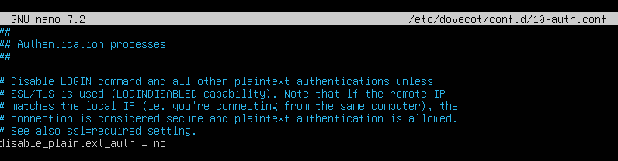
    - Configure user authentication (ensure the following line is present):
      - auth_mechanisms = plain login
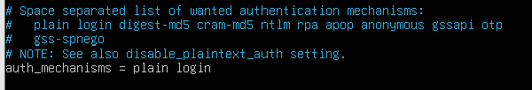
    - Explanation for each of these:
      - disable_plaintext_auth = no: Allows Dovecot to accept plain text passwords, which is necessary unless you are using SSL/TLS. While this is less secure without encryption, it’s common in basic setups or for internal networks
      - auth_mechanisms = plain login: Specifies the authentication methods allowed by Dovecot. "Plain" and "login" are basic authentication methods where the user’s credentials are sent in plain text (typically over an encrypted connection). This is necessary for compatibility with most email clients.
    - Start and Enable Services
  - Start and Enable Postfix and Dovecot
      - sudo systemctl restart postfix dovecot
      - sudo systemctl enable postfix dovecot
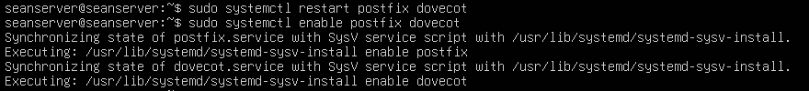
    - Explanation for each of these:
      - Restarting the services applies any configuration changes you made.
      - Enabling the services ensures that Postfix and Dovecot start automatically whenever the server reboots, maintaining continuous email service availability.
- Configure DNS for Email
  - Add MX Records
    - Edit your DNS zone file that we created in the last part/etc/bind/db.singleton-IT.com:
    - Add the following MX record as seen at the bottom of the screenshot:
      - @ IN MX 10 mail.singleton-IT.com.
      - mail IN A 172.20.10.10
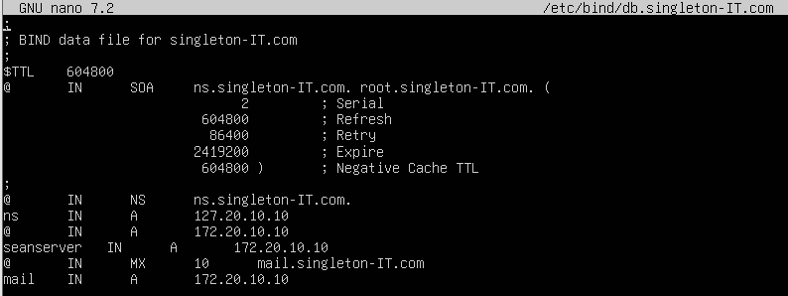
    - Explanation for each of these:
      - MX Record: Specifies which server is responsible for receiving emails for your domain, singleton-IT.com. The 10 is the priority of this mail server (lower numbers indicate higher priority).
      - A Record for mail.singleton-IT.com: Maps the mail server name to its IP address (172.20.10.10), allowing other mail servers to find and connect to your mail server.
  - Restart BIND9
      - Use the command “sudo systemctl restart bind9”
    - Explanation for this:
      - Restarting the BIND9 service applies the DNS configuration changes, ensuring that your DNS records are updated and accessible to other servers.

Verification

- Test Sending an Email Using the mail Command
      - “echo "Test email body" | mail -s "Test Email Subject" user@singleton-IT.com”
    - Explanation for this:
      - This command sends a simple test email from the command line. It echoes the message "Test email body" and sends it as the body of an email with the subject "Test Email Subject" to the specified email address (user@singleton-IT.com). This test helps verify that your Postfix configuration is working correctly for sending emails. Check it out by following the commands in this screenshot. We also verify here that it works as we can see the test to our hostname worked.
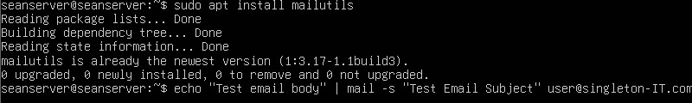
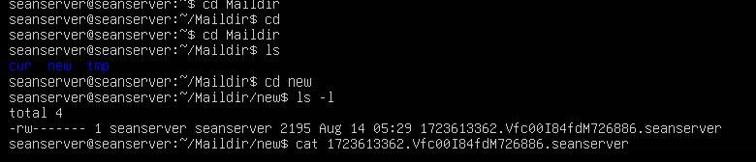
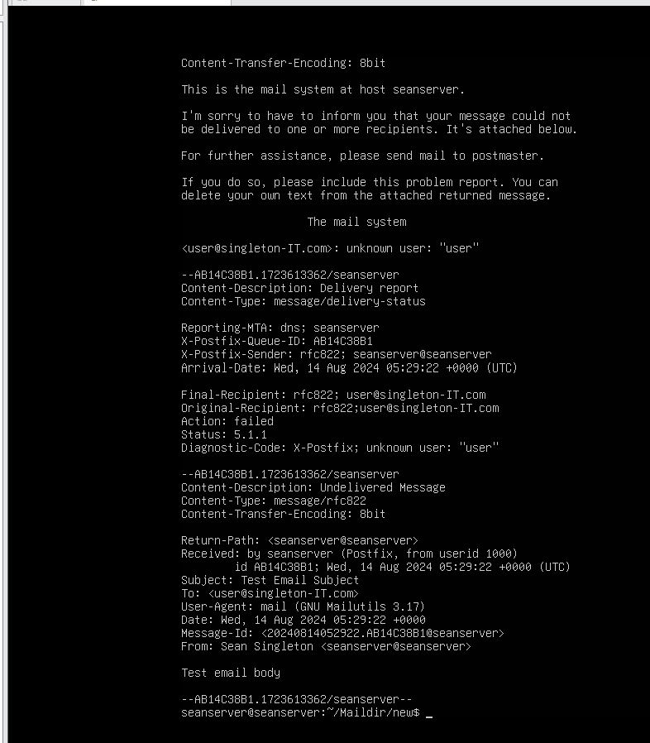
  - Test Receiving Email with Dovecot IMAP/POP3 Client:
    - Configure an email client (e.g., Thunderbird, Outlook) to connect to your server using the following settings, here we will use Thunderbird:
    - First we will add a new email account the info we add is the following:
      - Name: Sean Singleton
      - Email Address: user@singleton-IT.com
      - Password: which in my case for my user on mail server is Password1 then hit manual configuration then fill the following
      - Incoming Server (IMAP/POP3): mail.singleton-IT.com
      - Outgoing Server (SMTP): mail.singleton-IT.com
      - Username: The Linux system username.
      - Password: The Linux system password here is a screenshot of the layout of it.
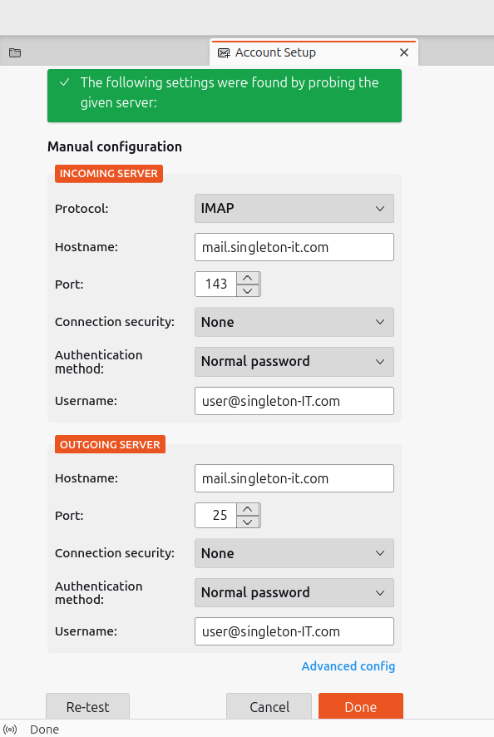
- Then click re-test and then done and your in and see this:
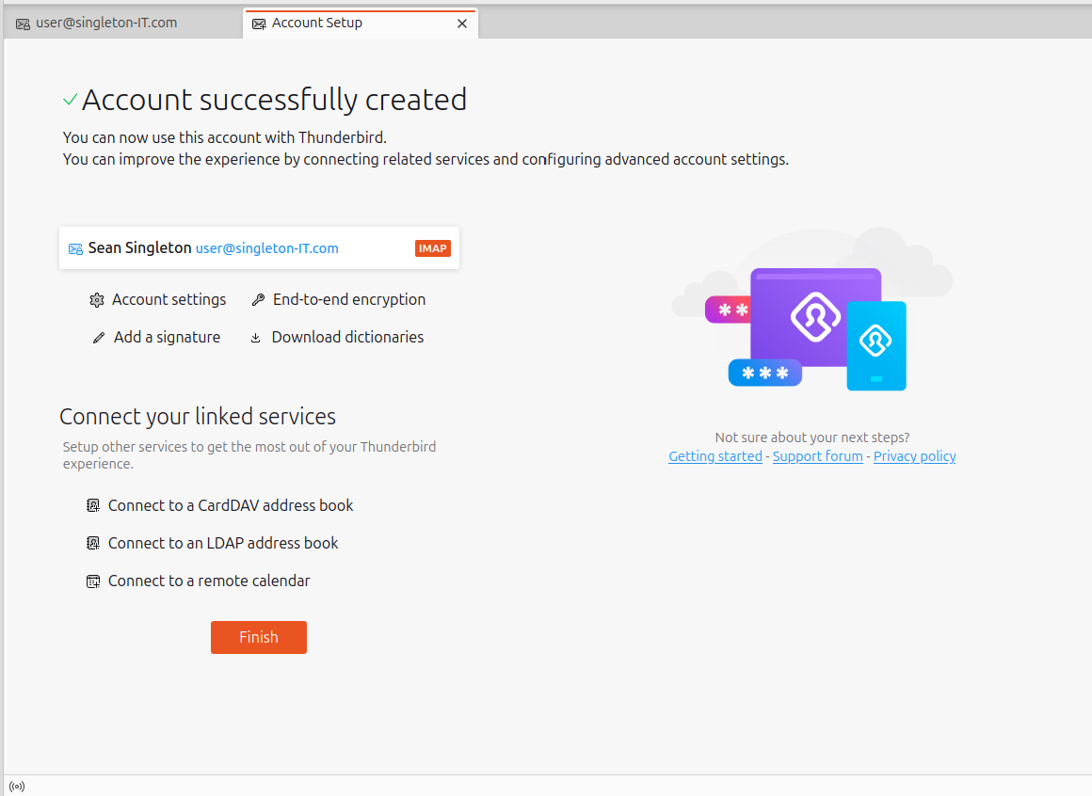

      - Click finish and we shall test sending an email to user, in this draft we say hey, and we can check too if it was seen in our server by checking our Mail directory “Maildir”
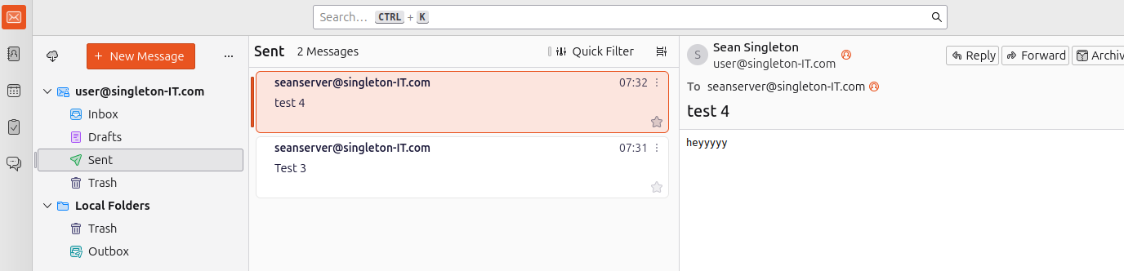
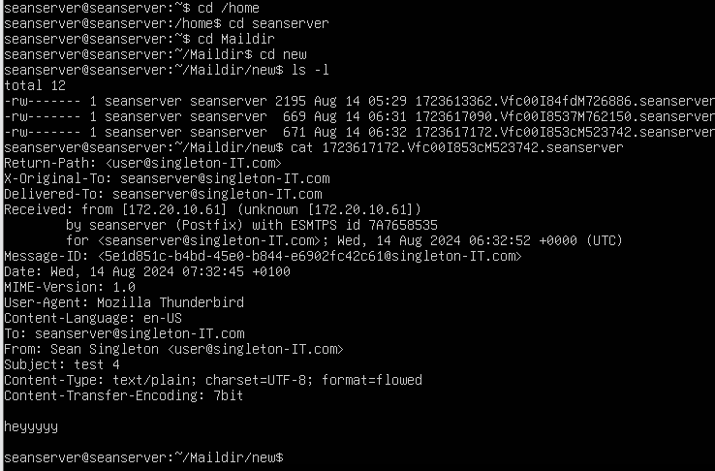
    - Explanation for this:
      - By configuring an email client and testing email retrieval, you verify that Dovecot is correctly serving emails over

Print Server (CUPS/Bonjour)

Service Description
The print server, configured using CUPS (Common Unix Printing System) and Bonjour (via Avahi), provides a centralized printing solution within a network, enabling users to manage and share printers seamlessly. CUPS acts as the backbone of the printing system, offering a powerful interface for managing print jobs, configuring printers, and supporting a wide range of printer models. Bonjour, on the other hand, facilitates automatic discovery of networked printers, allowing devices to easily find and connect to the print server without manual configuration. This setup ensures efficient, user-friendly printing capabilities across multiple devices in a networked environment.

Installation Steps
- The first step is we make sure that dhcp is set in our server so we can install cups and bonjour and the first command we use here is “sudo apt update” and “sudo apt upgrade -y” ensuring all packages are up to date.
- Now we install CUPS, The Common Unix Printing System (CUPS) is the printing system used by Ubuntu and the command to install it is this “sudo apt install cups -y”
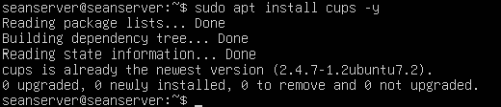

Configuration

- Once it is installed we will then start and enable CUPS service to start on boot with the following commands “sudo systemctl start cups” and “sudo systemctl enable cups” wee also use “sudo systemctl status cups” and we see below all the commands work as it is active and running.
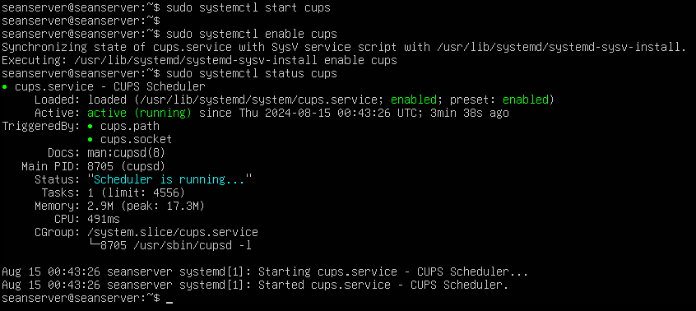
- Theen to manage our printers we must add our user to the lpadmin group with this command “sudo usermod -aG lpadmin $USER”
  - The command lpadminis the name of the group that manages printers and members in this group have the privilege to administer CUPS
- Check Authentication Settings in CUPS Configuration:
  - Using the command to enter the cups config file “sudo nano /etc/cups/cupsd.conf” in this file we make changes so that the listens to connections part listens to “0.0.0.0:631” why this is because tells the service to listen for incoming connections on port 631 across all network interfaces on the server. This setup ensures maximum accessibility but should be secured appropriately to prevent unauthorized access.
  - We also make sure that he AuthType is set to Default and that Require user @SYSTEM is present. This ensures that only users in the lpadmin group can access administrative functions as seen in the screenshot below for both parts here a and b

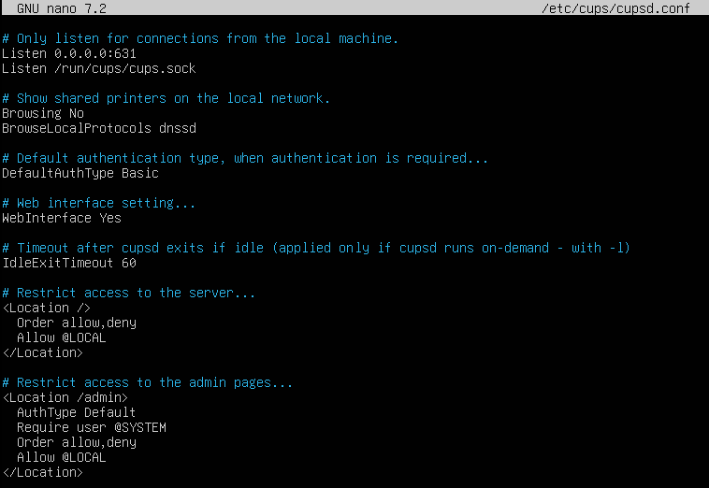
  - Once that is saved and exited we must restart cups using the command “sudo systemctl restart cups”

Testing and Verification
- To check if our user has the right privileges we can use the command “groups” and it shows all the privileges that the user has and here we see that we have the command
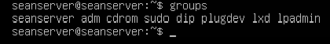
- We will check printer status to see if the printers are accepting jobs
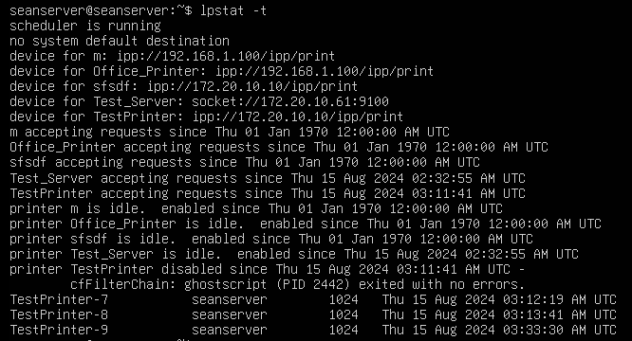
  - Here we will check the printer queue to see if the job is in a queue and as we see in the screenshot it is indeed in a queue meaning if a physical printer was connected then it would be dealt with

- Now we will print a page with the command “lp -d TestPrinter /etc/hostname” which is one of the printers I added on the web interface.
- We will set up a pdf virtual printer since I don’t have a physical printer to use, you can configure CUPS to use a virtual PDF printer, which will "print" documents to a PDF file instead of a physical printer for this use these commands to install it “sudo apt update” and “sudo apt install printer-driver-cups-pdf” also another install that is needed is this “sudo apt install xdg-utils” as this will be needed to read the pdf printed page you will be asked to proceed with the download so just type “y” when the option comes up as seen in the second screenshot below.
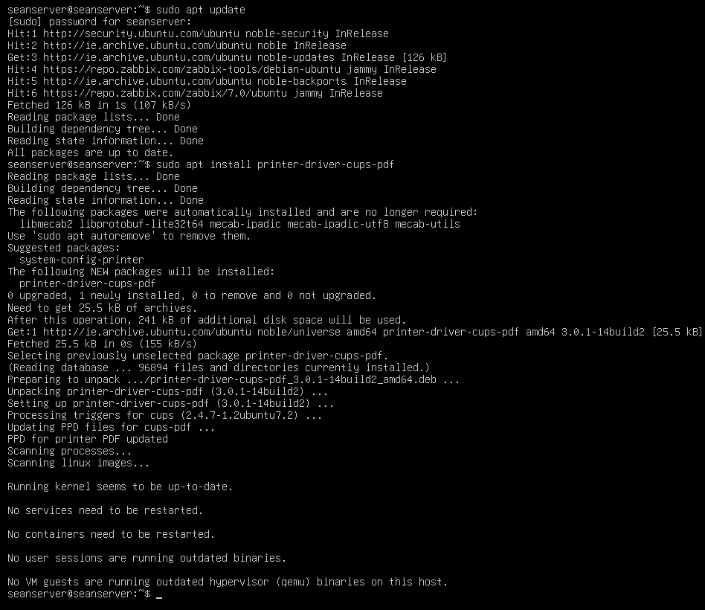
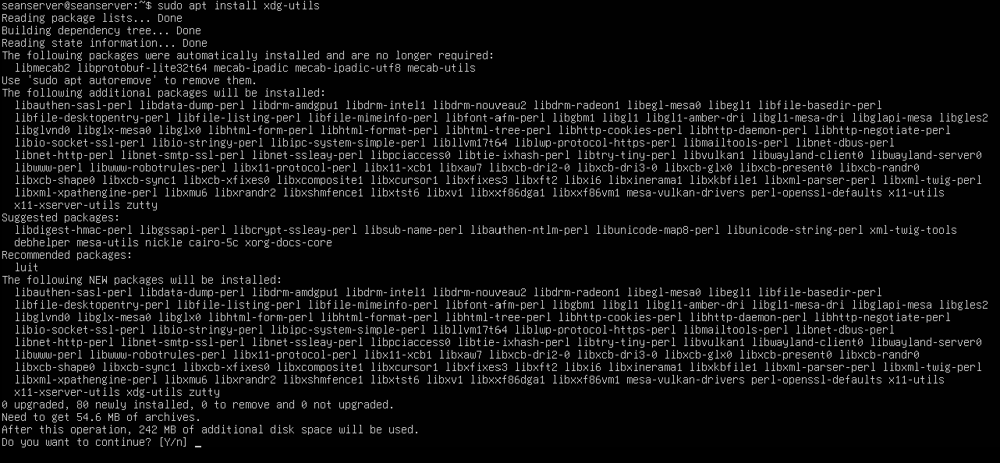
  - Now go to the desktop and go to the web interface and on cups admin navigate to manage printers and now we look for a printer called PDF which in this screenshot we see
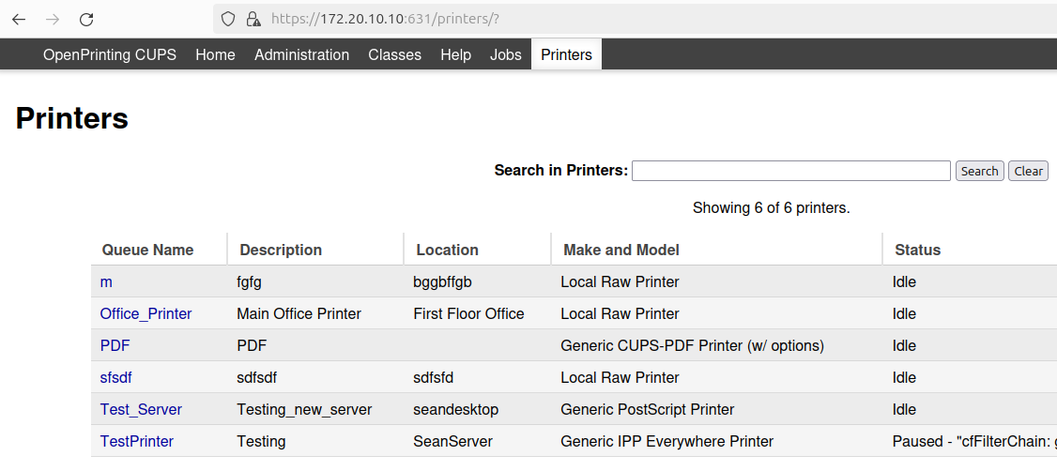
  - Now go back to the server and print a page using the following command “lp -d PDF /etc/hostname” and we go back to the webpage and check completed jobs and we see that the page was printed we see the pdf file is called “PDF-17” and in the web page it says that this PDF page was printed as it says completed.
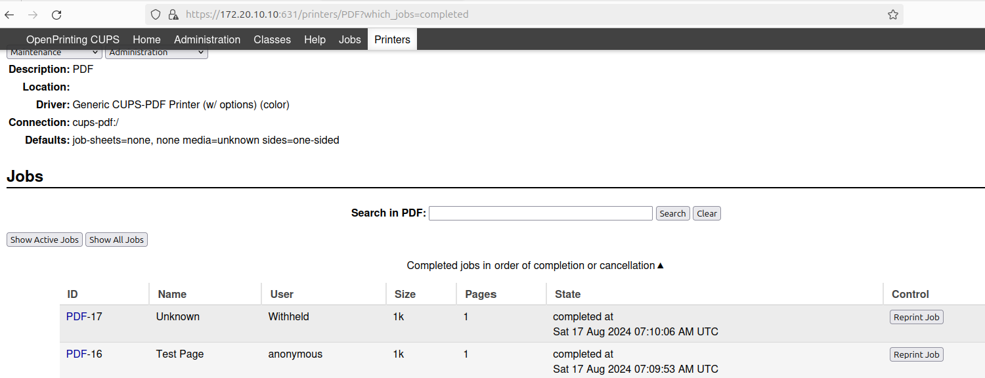
- Example set up of a printer
  - First, we must go to admin so in the url you can just add /admin or click on administration and it asks you to sign in and just click sign in the login is the same as your servers login.
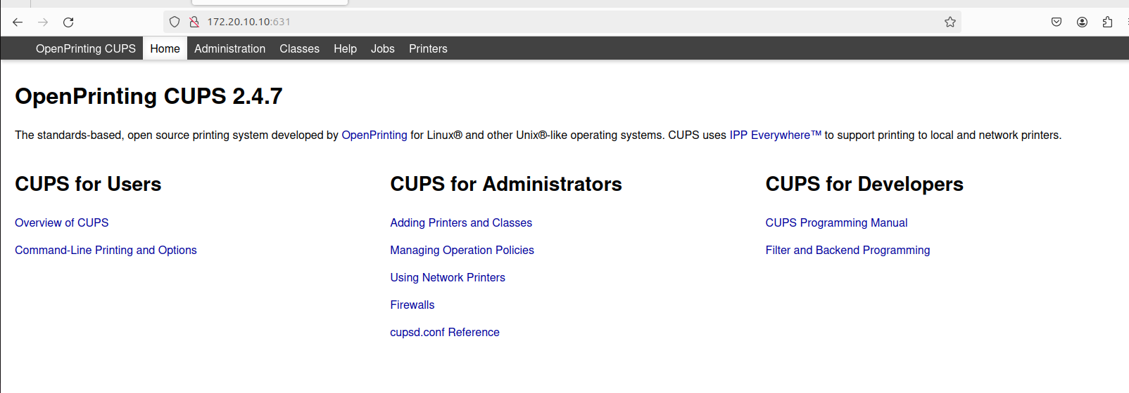
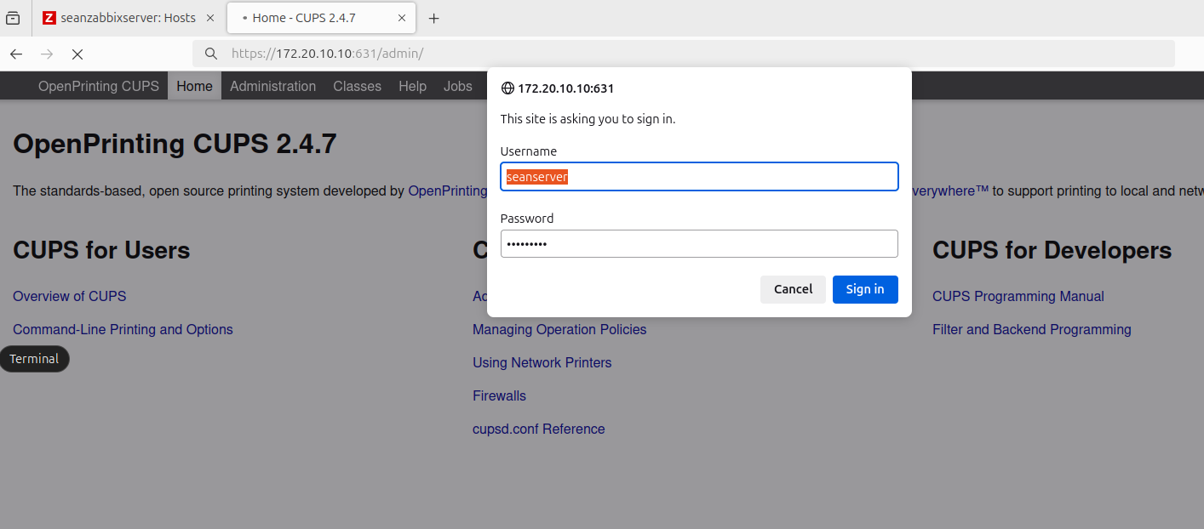
  - Now we are in the page where you can add printers here we will choose add printer.
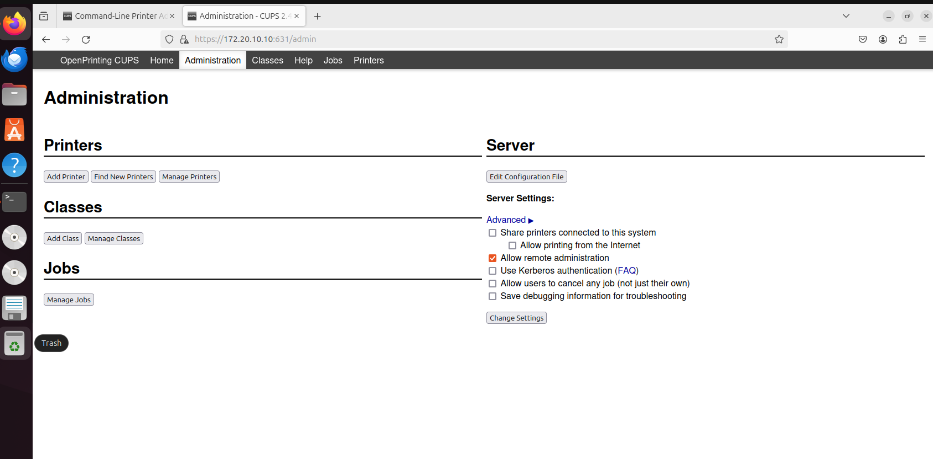
  - For this next part you get an option of printers for example im going to choose APPSocket but choose whichever printer you want to.
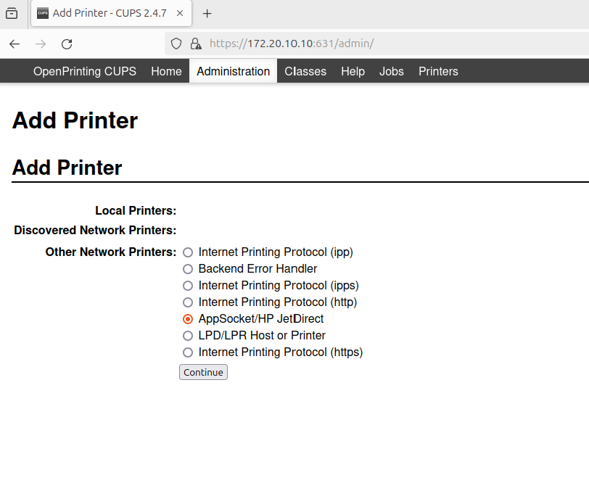
  - For this one we will use the connection “socket://172.20.10.61:9100” we add the ip of the desktop and the port is default for socket.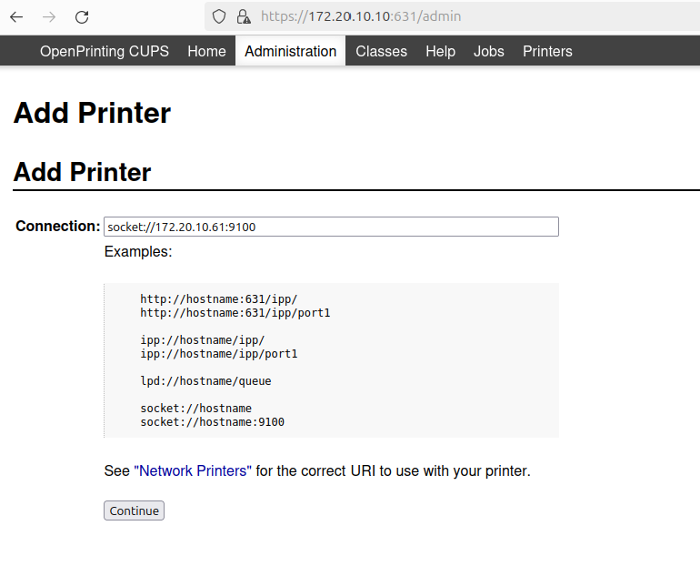

  - Finally for this next part you can name these anything but just make sure to tick share this printer is the only necessary part here and then click continue.

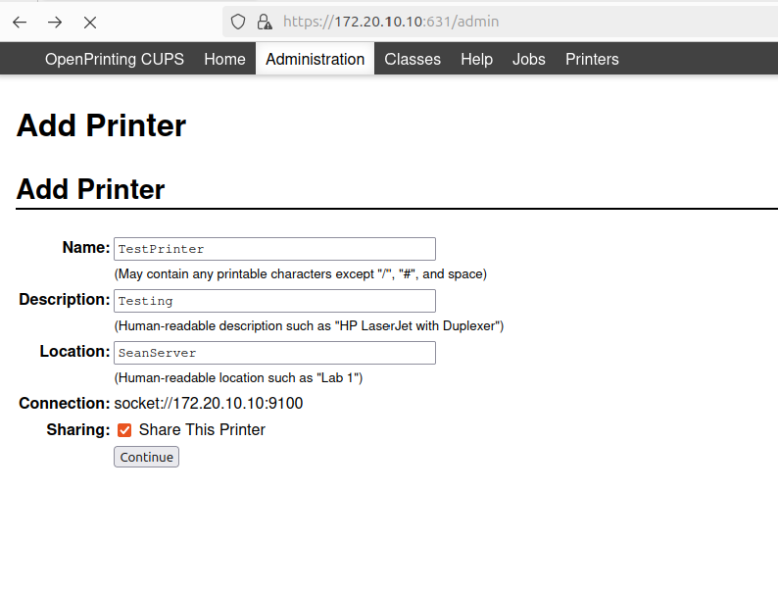
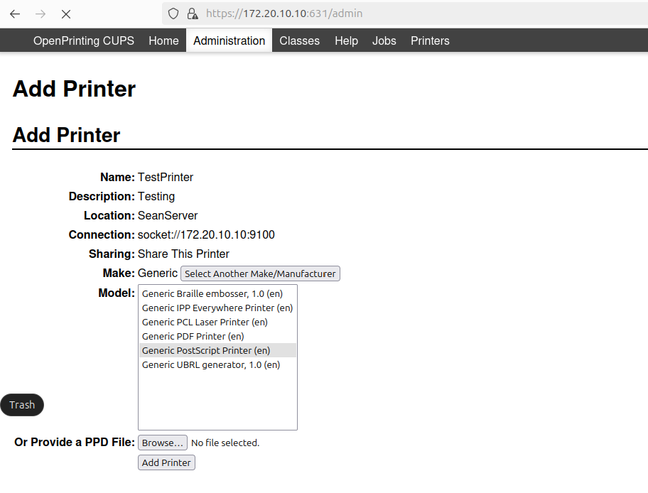
  - Now we must choose the make and model and for socket here we will choose Generic as the make and for the model PostScript Printer(en)

  - Now you can see that our printer was created and in printer options just set default options for printer. In manage printers choose your created printer and just under your printer name theres a maintenance scroll down bar open that and choose print test page and then hop over to server and verify that it came through using the command “lpstat -p TestPrinter” for the TestPrinter just use the name of your printer and then the command “lp -d TestPrinter /etc/hostname” it should show the printed page name
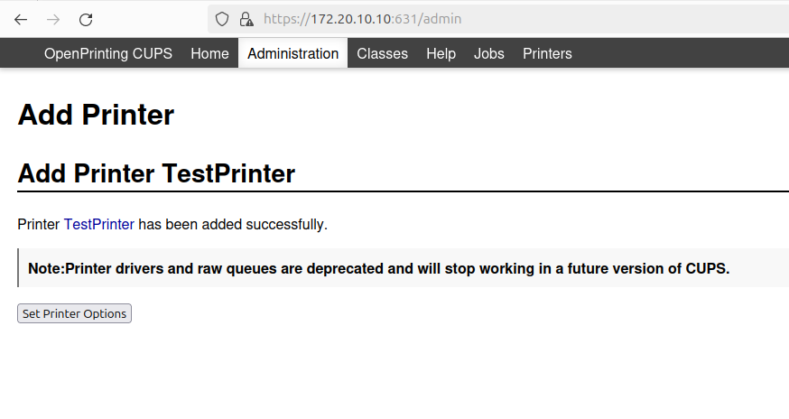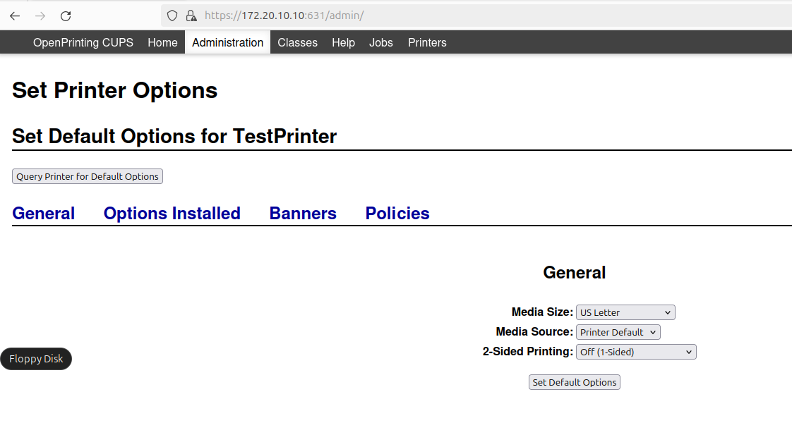
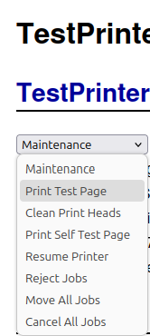
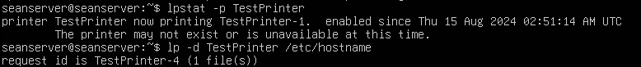

SSH Server

Service Description
An SSH (Secure Shell) server provides a secure and encrypted method for remote login and command execution on a server. It allows administrators and users to securely access and manage systems over an unsecured network, such as the internet. The SSH server ensures data confidentiality and integrity through encryption, supports secure file transfers, and enables secure tunnelling of other protocols. It's a fundamental service for system administration, remote support, and secure communications between systems, ensuring that sensitive data and login credentials are protected from unauthorized access.

Installation Steps
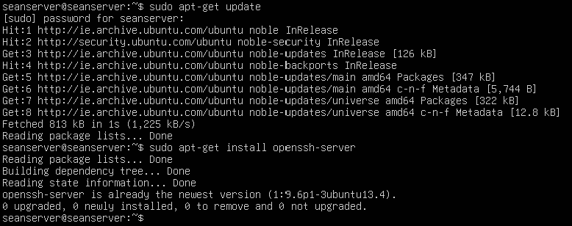

Configuration
- After the installation we must start and enable ssh so we use the commands “sudo systemctl start ssh” and “sudo systemctl enable ssh” and to check if its active and running we use the command “sudo systemctl status ssh”
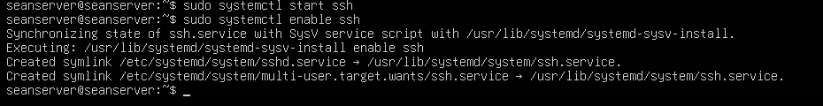
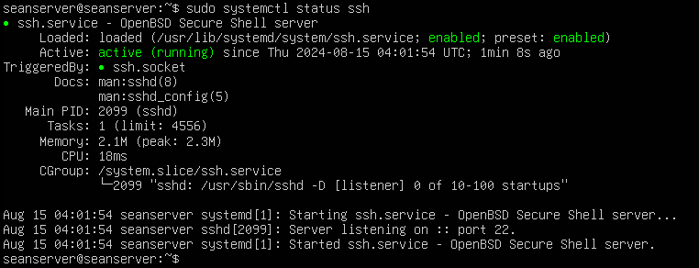
- here there is 3 screenshots of all the SSH configurations made this is to enhance security such of the changes we made are:
  - Change the SSH “Port 2222”
    - Changing the SSH port from the default (port 22) to a non-standard port, like 2222, is a common security practice, reduces automated attacks also basic attacks adds that layer of defense and reduces noise in the logs.
  - Disable Root Login “PermitRootLogin no”
    - his prevents the root user from logging in directly via SSH
  - Disable Password Authentication “PasswordAuthentication no”
    - This disables password-based logins, forcing users to authenticate with SSH keys
  - Ensure Public Key Authentication is Enabled “PubkeyAuthentication yes”
  - Restrict User Access “AllowUsers seanserver”
    - This allows only the specified user(s) to log in via SSH
  - Limit Login Attempts “MaxAuthTries 3”
    - This reduces the risk of brute-force attacks by limiting failed login attempts
  - Disable Unnecessary Features “X11Forwarding no”
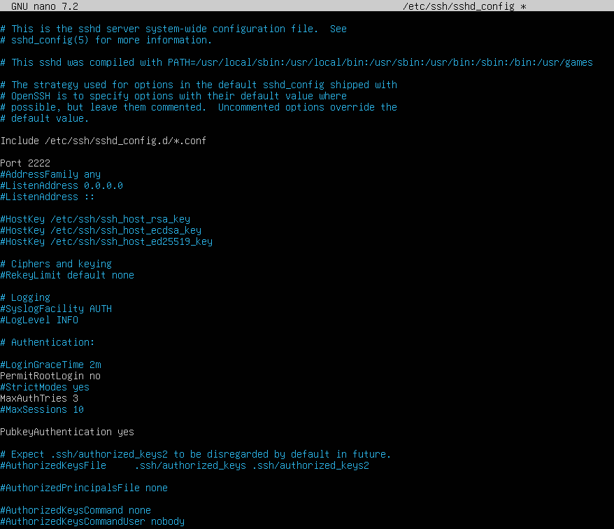

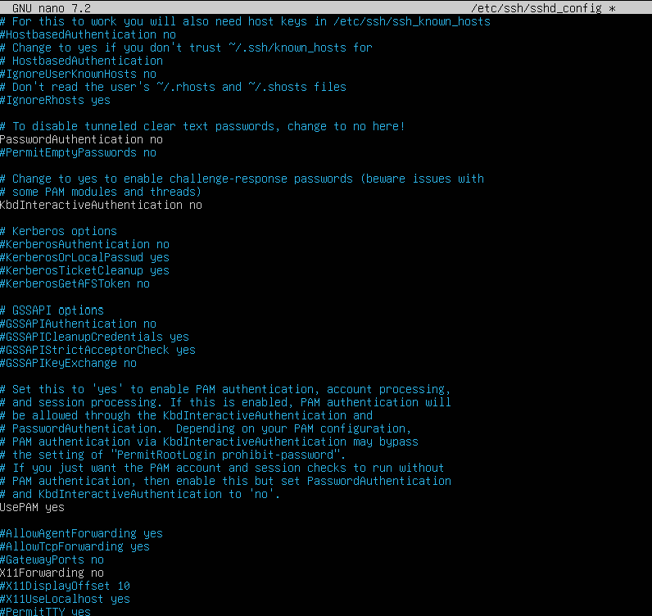

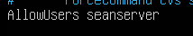
- Restart SSH to Apply Change using the command “sudo systemctl restart ssh”
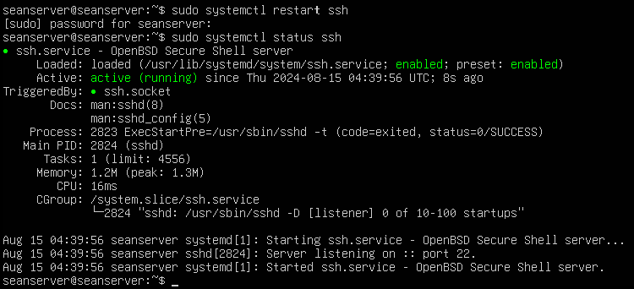
- Set Up SSH Key-Based Authentication
    - Here we generate the ssh key pair and we copy the public key to seanserver with the following commands “ssh-keygen -t rsa -b 4096” and for copying it to the server “ssh-copy-id seanserver@172.20.10.10”
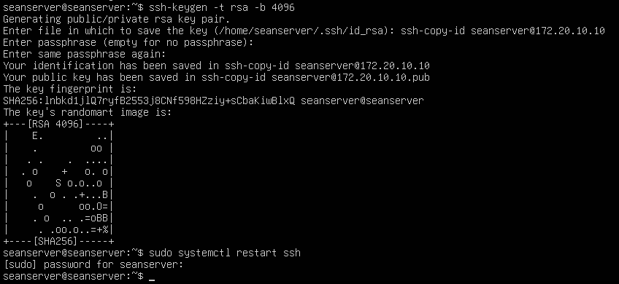

Testing and Verification
- Verify SSH Access
  - To ensure that the SSH server is working correctly, we will connect to seanserver via SSH from another machine using this command “ssh -p 2222 seanserver@172.20.10.10”
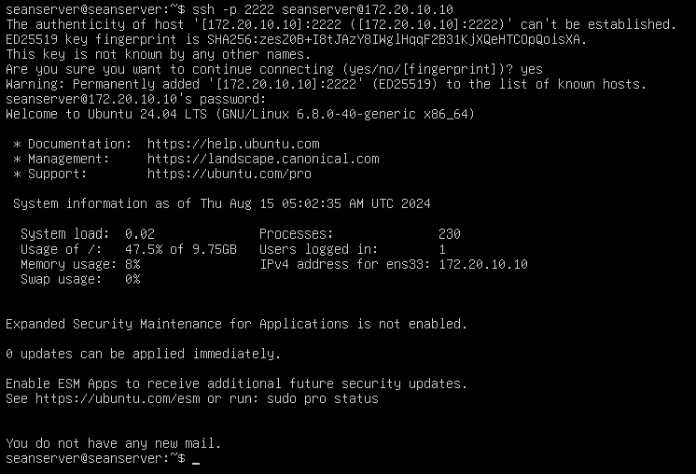
- Verify and Monitor SSH Connections:
  - To view our active SSH sessions use the command “who”
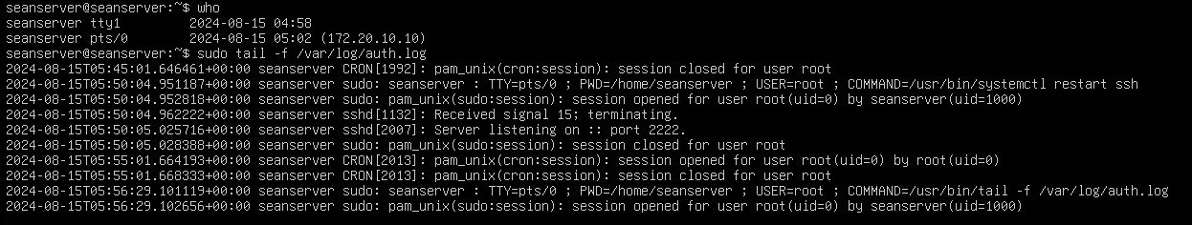

  - The above shows that our SSH connection is working
    - Explanation of What You’re Seeing:
      - who Command:
        - The who command lists currently logged-in users and their session details.
        - In your output, seanserver is listed as logged in via pts/0, which corresponds to an SSH session connected from 172.20.10.10.
      - sudo tail -f /var/log/auth.log:
        - The tail -f command is used to monitor the auth.log file in real-time, showing new entries as they are written.
        - Key Entries:
          - Session Opened: The log shows when a new session is opened (e.g., session opened for user root), which is normal when you use sudo.
          - Server Listening on Port 2222: This confirms that the SSH server is correctly listening on the new port (2222).
          - Commands Executed: You can see the commands executed with sudo, like restarting the SSH service and tailing the log file.
- Now I will verify ssh connection from the desktop when we load up the desktop just type in the command “ssh -p 2222 seanserver@172.20.10.10” and after we signed in we will be asked to type in “yes” then hit enter and use another command to verify that we can use commands on our seanserver on our seandesktop using “sudo tail -f /var/log/auth.log” which monitors the server logs will show you the authentication attempts and any relevant messages while you are logging in from seandesktop.
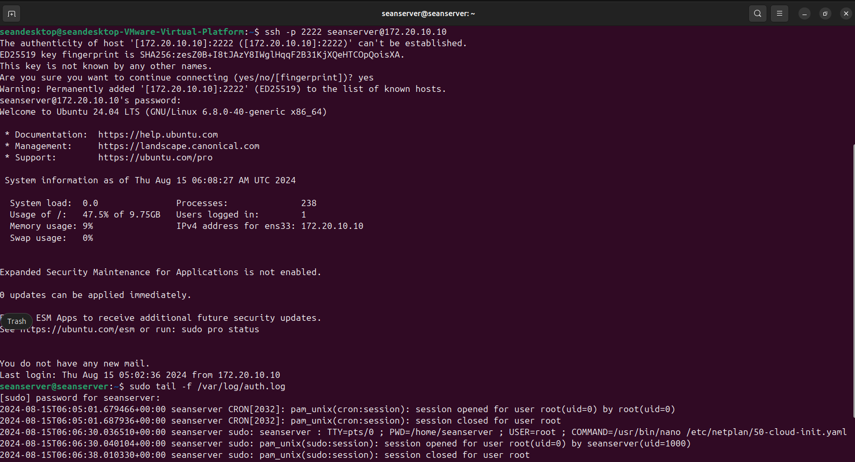
- File transfer from desktop to desktop
  - This is another way to verify ssh is operational
    - First we create a file on our desktop using touch I called it testfile.txt so the command used was “touch ~/testfile.txt”
    - Now we hop over to the server and make sure we are logged into our seanserver via ssh with the command we used before “ssh -p 2222 seanserver@172.20.10.10”
    - Then we ls to verify that the file we created has transferred over to our server just using “ls”

DHCP Server

Service Description
The DHCP (Dynamic Host Configuration Protocol) server is a crucial network service that automatically assigns IP addresses and other essential network configuration parameters to devices on a network. By dynamically managing the allocation of IP addresses, a DHCP server simplifies network administration, reduces the risk of IP address conflicts, and ensures that devices can easily connect to and communicate within the network. This service is particularly beneficial in environments with many devices, as it streamlines network configuration and allows devices to seamlessly join the network without manual setup

Installation Steps
- First step is to update the packages using the command “sudo apt-get update” the next command will install the DHCP server package “sudo apt-get install isc-dhcp-server” you will be asked to proceed with the install so type “y” and press enter.
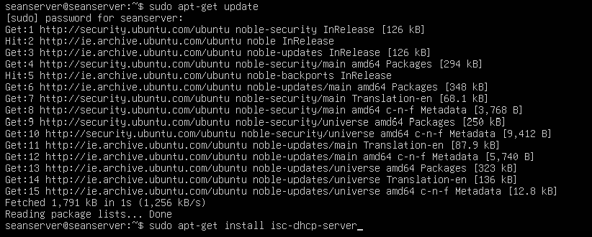

Configuration
- Now we will configure the DHCP server and to do this we must access the dchp.conf file and the command for us to enter this is “sudo nano /etc/dhcp/dhcpd.conf” here we will make changes to the file as you will see.
  - Now we must define the network and IP Address range so we can specify the network segment that the dhcp server will be managing which includes these IP ranges it will assign to clients.
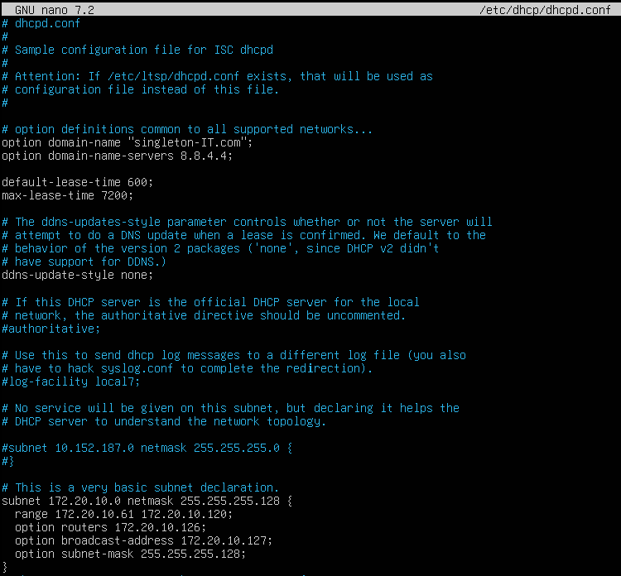
  - Explanation for the changes I made to this config file:
    - Option domain-name and Option domain-name-servers: We use our domain name we have been using throughout the project “singleton-IT.com” and our DNS which is “8.8.4.4”
    - Range: The pool of IP addresses “172.20.10.61 to 172.20.10.120” that the DHCP server will assign to clients.
    - Routers: The default gateway “172.20.10.126” that clients will use to access other networks.
    - Broadcast Address: The broadcast address “172.20.10.127” for the network.
    - Subnet Mask: The subnet mask “255.255.255.128” used by the network.
- Configure the DHCP server interface:
  - Using the command “sudo nano /etc/default/isc-dhcp-server” to enter this config file and below we will see the changes to make in this file.
      - Set the interface which in our case our interface is “ens33” you can check using the command “ip a”
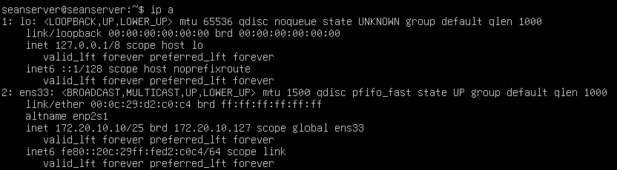
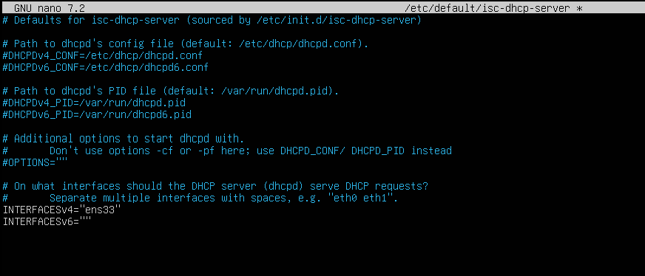
        - We can see in the second screenshot we set the INTERFACESv4=”ens33” which is our servers network interface.
- Now start and enable and verify that the DHCP server is working and running:
  - We do this using the commands “sudo systemctl start isc-dhcp-server” and “sudo systemctl enable isc-dhcp-server” and to verify if its working run the command “sudo systemctl status isc-dhcp-server” to see if its running and active and you can see it is in the screenshot below.
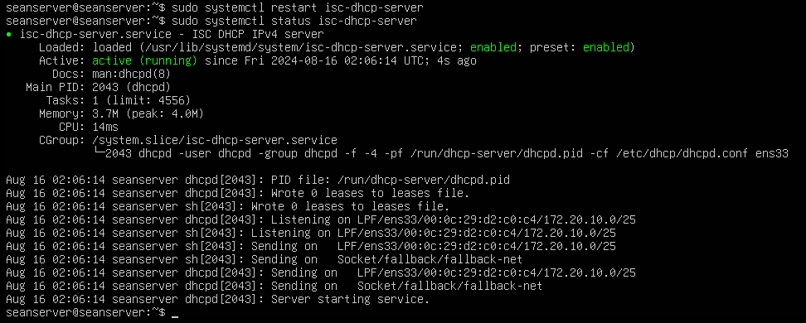

Testing and Verification
- For this part make sure that both vms’s are set to host only and have static ip’s setup so that no other dns servers from local network interfere here and for the first part we will on our server use the command “sudo tail -f /var/log/syslog | grep dhcp” this command will monitor and show only the lines containing "dhcp" as they are added to the log file in real-time so we can track our output of DHCP related data.
- Moving to our desktop now on a terminal use the commands “sudo dhclient -r” followed by “sudo dhclient” the -r flag tells dhclient to release the current lease, and running dhclient again requests a new lease from the DHCP server.
- To verify we use the command “ip a” we should now see a new ip within the range we specified by our DHCP server here below in the screenshot you see we got the new IP “172.20.10.62”
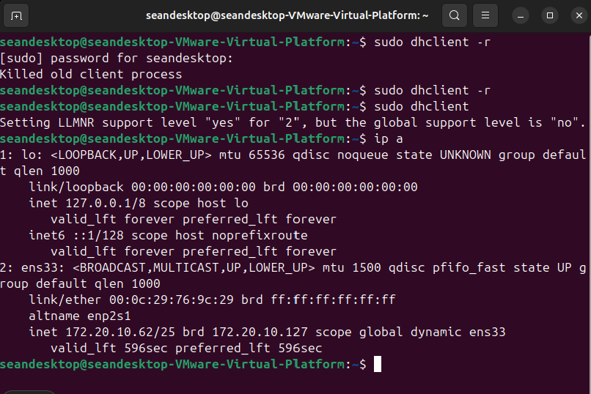
- Returning to our server which we are capturing the DHCP related data you can see that the data shows that the DHCP server received a DHCPDISCOVER request from the client, offered an IP address, and then acknowledged the request with a DHCPACK. Which is shown in this screenshot.
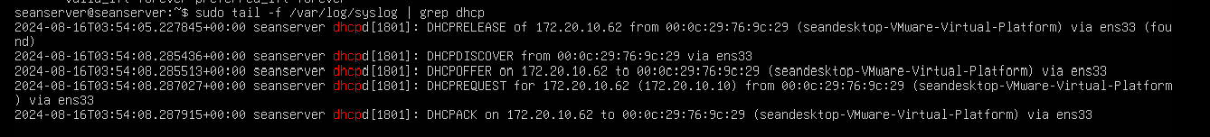

Network Management System

Service Description
Zabbix is a powerful, open-source Network Management System (NMS) designed to monitor the performance and availability of network devices, servers, and services. It provides real-time insights, customizable alerts, and historical data analysis, enabling proactive management of IT infrastructure. With Zabbix, organizations can ensure network reliability, quickly identify and resolve issues, and optimize overall system performance, making it an essential tool for maintaining a robust and efficient network environment.

Installation Steps
For both these installation steps remember to use bridged network so that we have internet connection to download on both server and desktop.
- Server Installations steps:
  - Firstly update our package lists and upgrade any existing packages with the commands “sudo apt-get update” and “sudo apt-get upgrade -y”
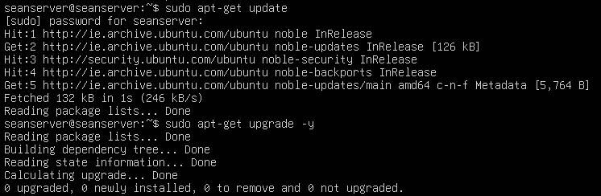
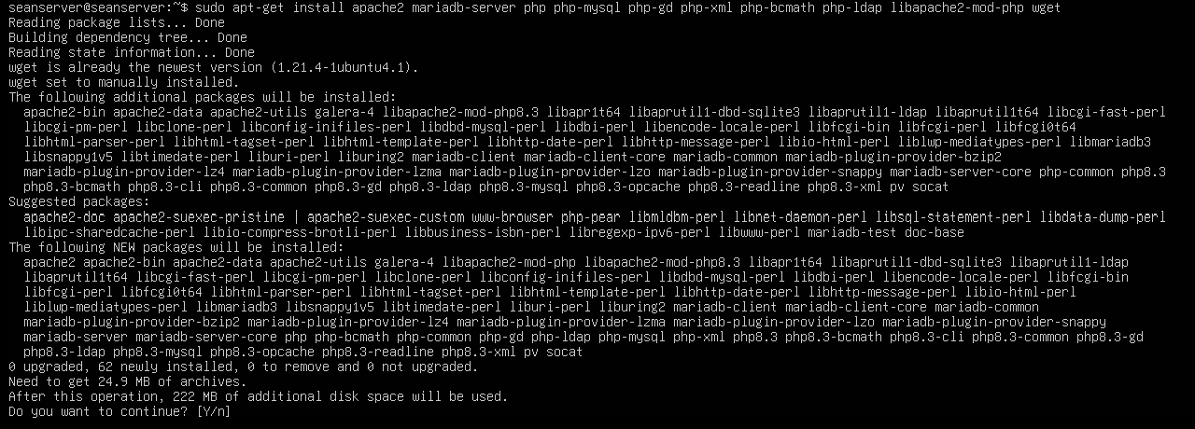
  - Install Required Dependencies and to do that we install Apache web server, MySQL and PHP along with other necessary dependencies using the command “sudo apt-get install apache2 mariadb-server php php-mysql php-gd php-xml php-bcmath php-mbstring php-ldap php-xmlwriters php-sockets php-mbstring libapache2-mod-php wget” you will be asked to continue after entering this command and just type “y” and enter and itll finish the download.
Now proceed to configuration to configure Mariadb.
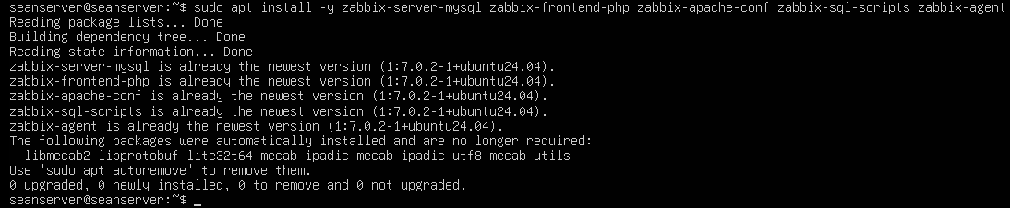
  - Install Zabbix Server and Frontend, the first command for this install is the repository of Zabbix https://repo.zabbix.com/zabbix/7.0/ubuntu/pool/main/z/zabbix-release/zabbix-release_7.0-2+ubuntu22.04_all.deb” then “sudo dpkg -i zabbix-release_7.0-2+ubuntu22.04_all.deb” then we make sure our packages are up to date with “sudo apt update” and finally “sudo apt install -y zabbix-server-mysql zabbix-frontend-php zabbix-apache-conf Zabbix-sql-scripts zabbix-agent” for the rest of the setup of the Zabbix server go to the configure section for Zabbix server

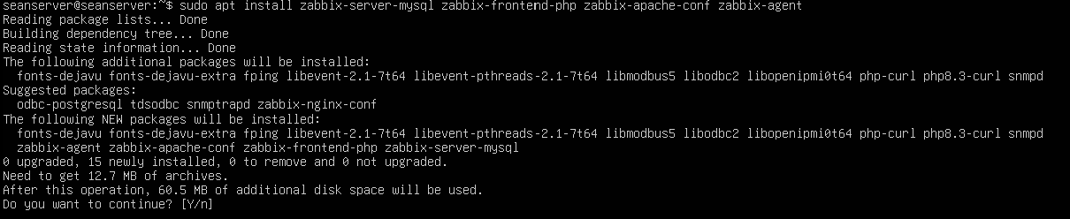
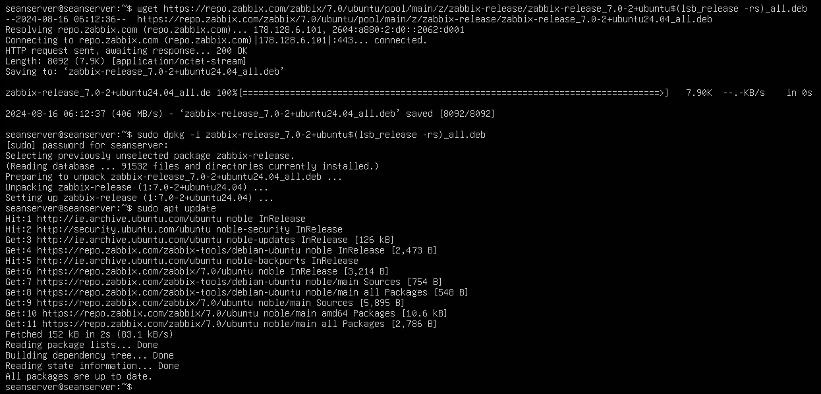
    - When this command is entered just above you get asked to continue and for this just type “y” and enter and the download will continue
  - Install PHP
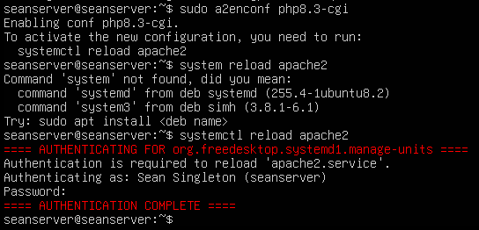

Configuration
- Now we will configure our Mariadb:
  - we will secure our mariadb and create a database for Zabbix heres each step by step of how to configure it.
    - “sudo mysql_secure_installation” This secures our mariadb installation and creates a db for us.
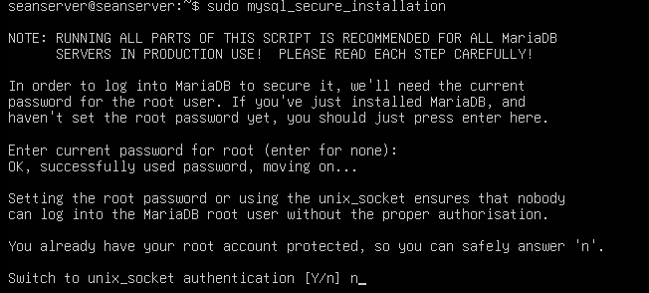
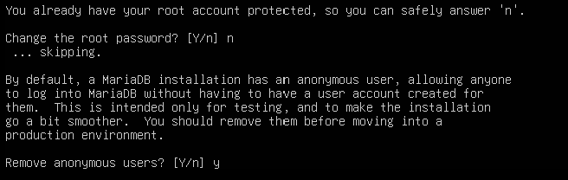
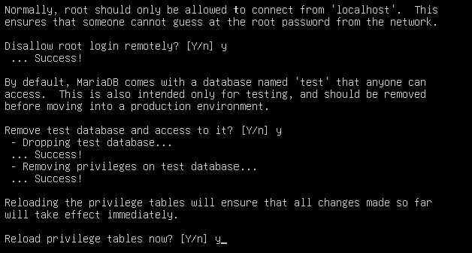
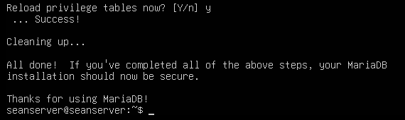
    - Once we have the db setup we will now log into the created db using the command “sudo mysql -uroot -p” from here we will be asked for our password which is our server password in this case it is “Password1” now once we are in we must
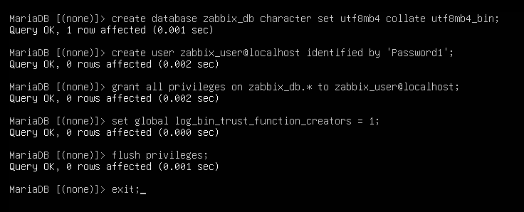
          - These commands create a database Zabbix_db, create a user Zabbix_user@localhost with a specified password, and grant that user full privileges on the Zabbix_db database, allowing them to manage it. The user is restricted to connecting from the local machine.
- Configure Zabbix server:
  - Initialize Zabbix db using the following command first find the path of the initial schema and data for that we can use the find command which is “find /usr/share/ -name “server.sql.gz”” and once we find the path we use the command to initialize the schema and data into the db we created “sudo zcat /usr/share/ zabbix-sql-scripts/mysql/server.sql.gz | mysql –default-character-set=utf8mb4 -uzabbix_user -p “Password1” zabbix_db”

  - Now we disable log_bin_trust_function_creators after importing db schema we log into our mysql here with the command “sudo mysql -uroot -p” and enter the password which here is “Password1”
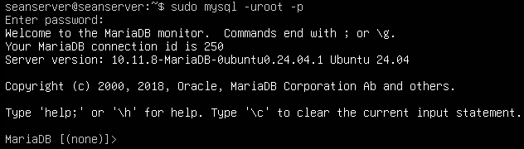
    - The command to disable log bin trust function creators is setting its value to 0 and here it is “set global log_bin_trust_function_creators = 0;”
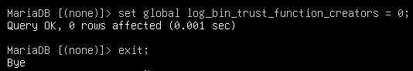
  - For us to configure our Zabbix server we must edit the config file for our Zabbix server and to get here we use the command “sudo nano /etc/zabbix/zabbix_server.conf”
    - When in here we will update the following parameters:
      - We will make “DBName=Zabbix_db”, “DBUser=Zabbix_user” and “DBPassword=Password1” the password is whatever the database password that was set in the setup of the db which in this case here is “Password1” all seen in screenshot below.

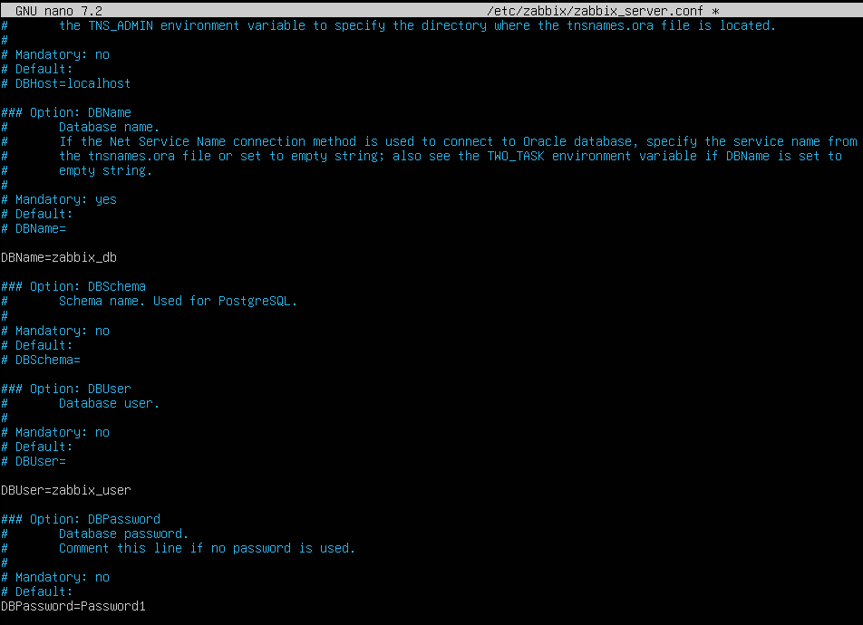
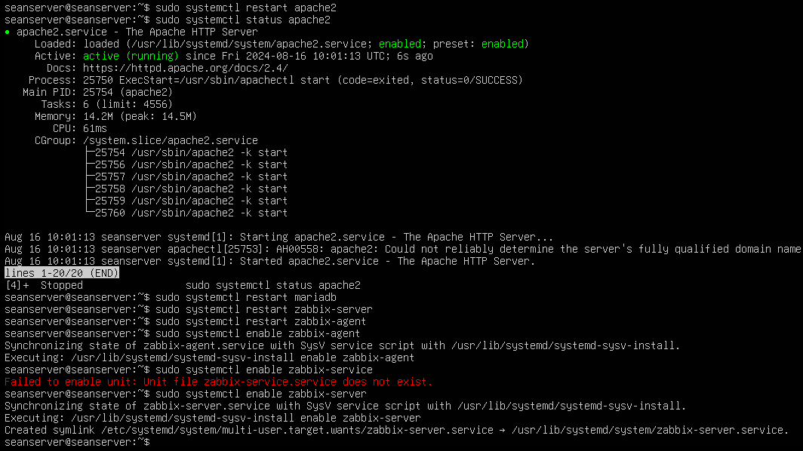
  - Now we will enable Zabbix server and Zabbix agent and to do that we must use these commands “sudo systemctl restart apache2”, “sudo systemctl restart mariadb”, “sudo systemctl restart zabbix-server”, “sudo systemctl restart zabbix-agent”, and then enable Zabbix server and Zabbix agent with the command “sudo systemctl enable zabbix -server” and “sudo systemctl enable zabbix-agent” in the screenshot below we will see the zabbix-agent and zabbiz-server aree both running and active.
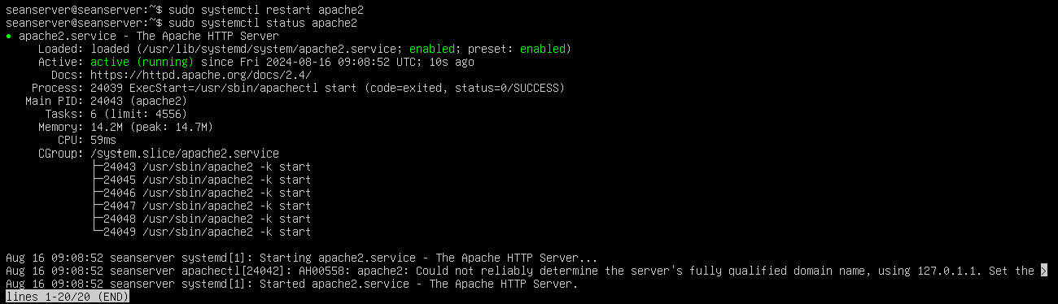
- Configure PHP
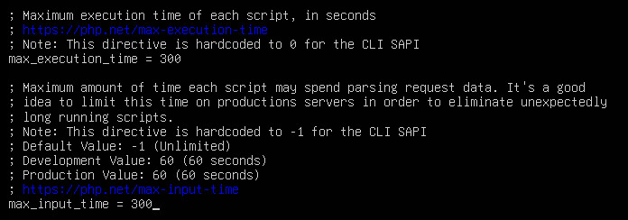
  - here we change the max execution time and the max input time
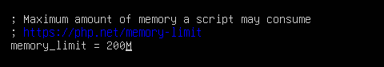
  - next we will configure the memory limit and change it to 200M
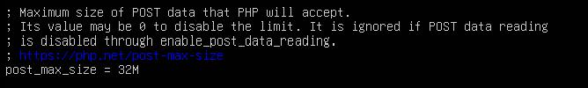
  - next up is the post max size which will be changed to 32M
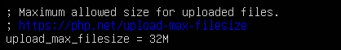
  - Then the upload max filesize which will be 32M
  - Finally the timezone setup and in my case it is Europe Dublin
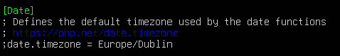
  - Once those config changes are complete save and exit and then use the command “sudo systemctl restart apache2” and “sudo systemctl status apache2” to check if its active and running.

Testing and Verification
- For verifying if all the installations and configuring was correct:
  - we will now verify this on our desktop, make sure that the networks are both set to host only with static Ip set on both so there’s communication between the vms like shown at the very start of this report. Now in the server we must first verify that the zabbix-server and apache2 servers are both running and active along with Zabbix-agent here below are the screenshots to verify that they are active and running.
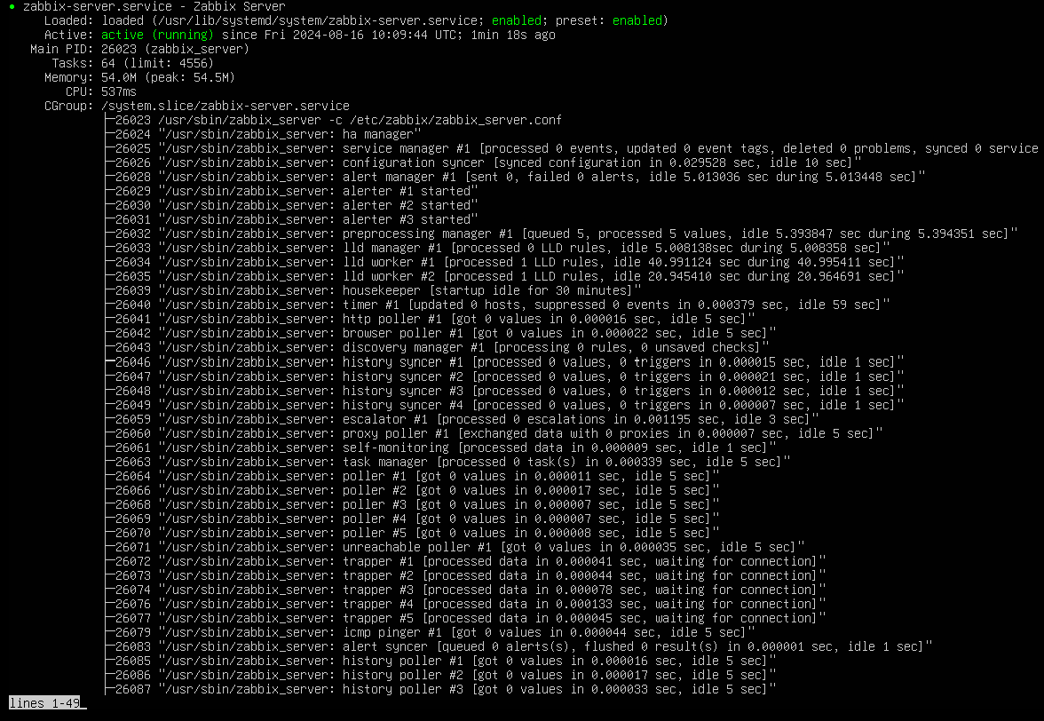
Zabbix-server
Zabbix-agent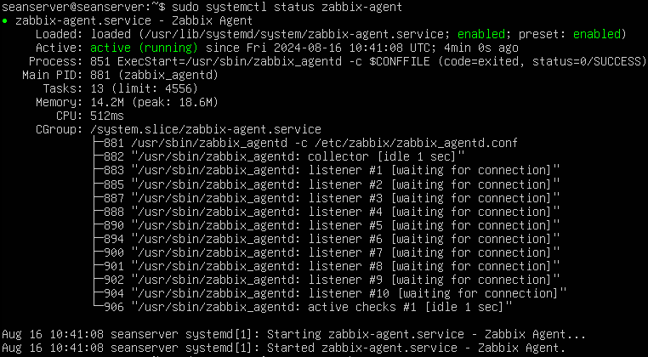
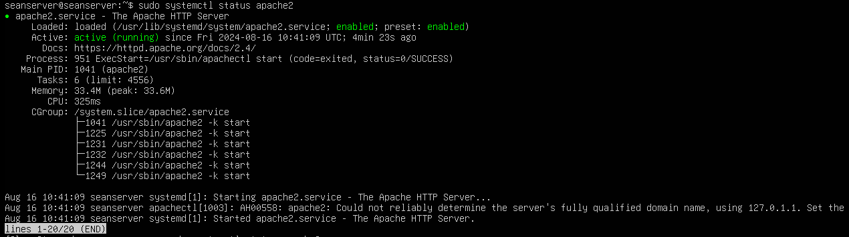
Apache2

- Accessing Zabbix from desktop:
  - Now to do this we take our server IP which is 172.20.10.10 and we use it in our url for Zabbix so it will look like this “http://172.20.10.10/zabbix” and as we see below we have successfully installed and configured our Zabbix.
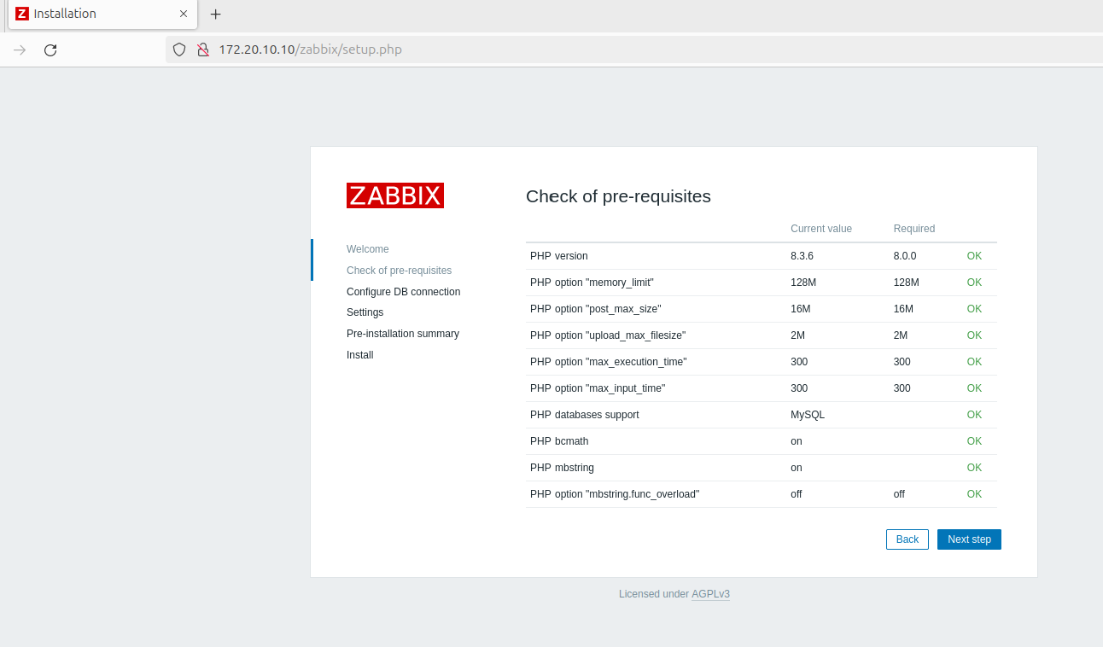
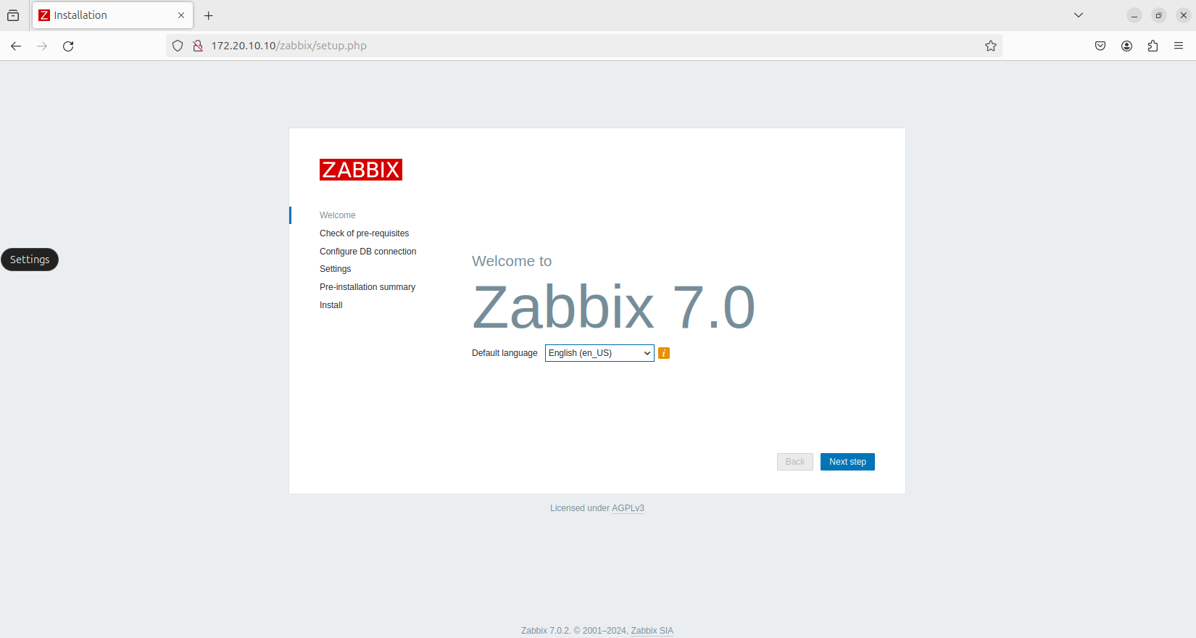

  - When setting up our zabbix web client in the configure DB connection we need to make sure we use the same db name we set up in the server which was “zabbix_db”, our username “zabbix_user” and finally our passwordwe used “Password1” everything else stays the same.
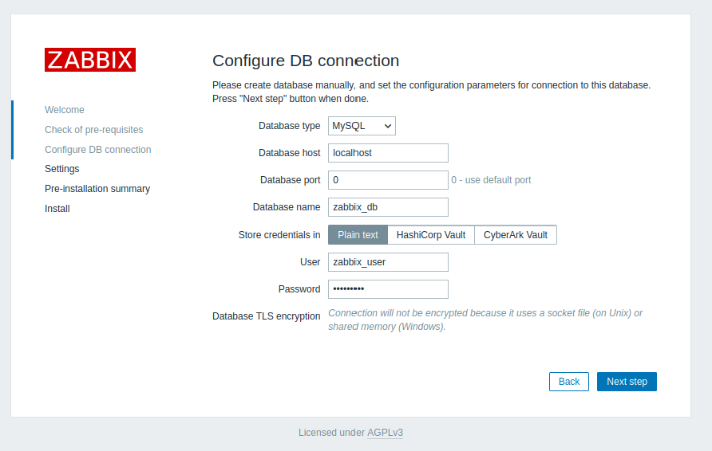
Click next step and a pop up will appear click not now for now.
  - For this next part in the settings you can name the server anything I called mine “seanzabbixserver” and the default time to your timezone in my case its Dublin/ Europe and default theme I left the same.
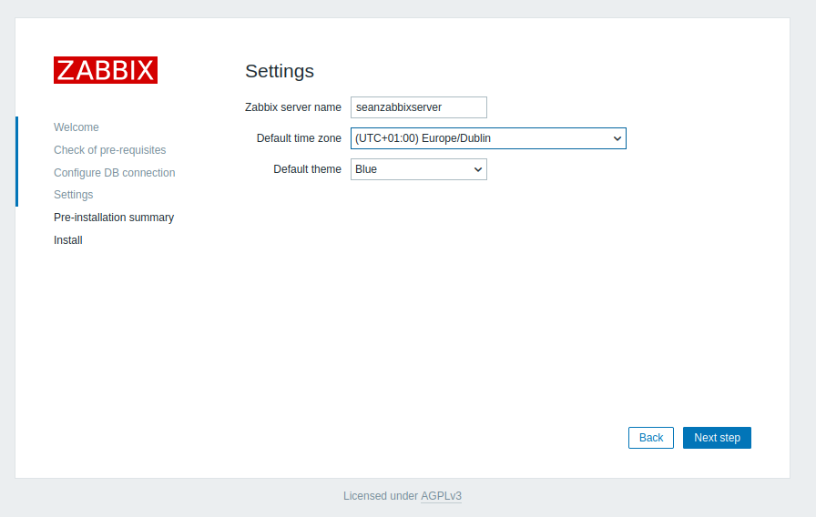

  - Now we install by clicking next step
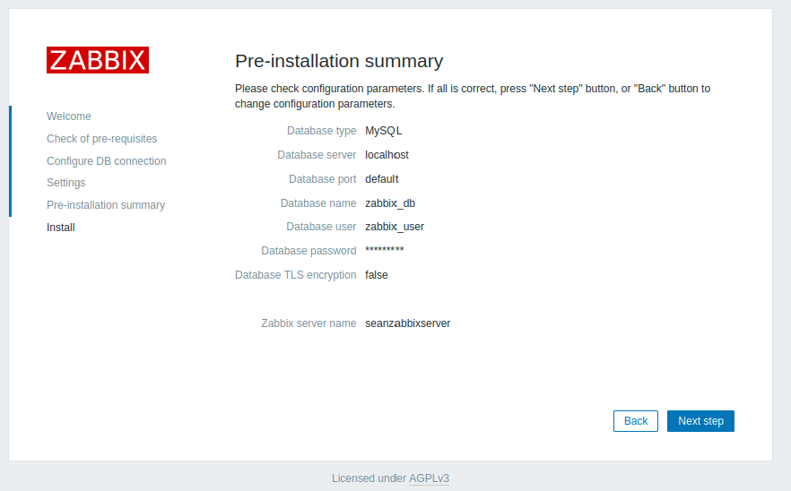
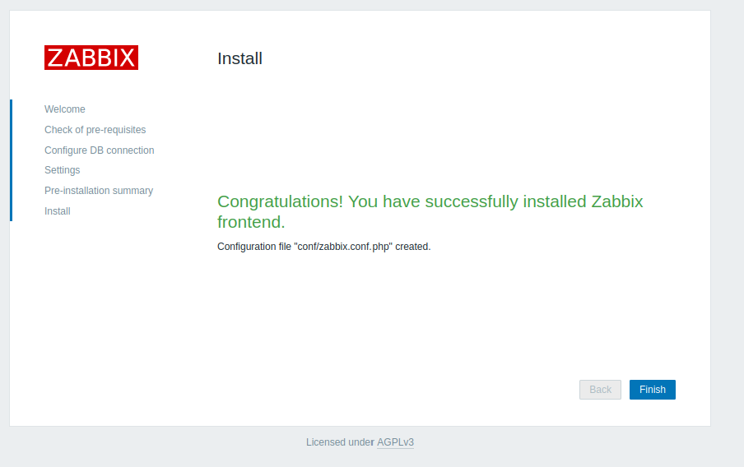
  - The default username and password for Zabbix is USERNAME “Admin” capital A must be used for admin and the password is lower case z “zabbix”. Now we are in zabbix as seen in this screenshot below.
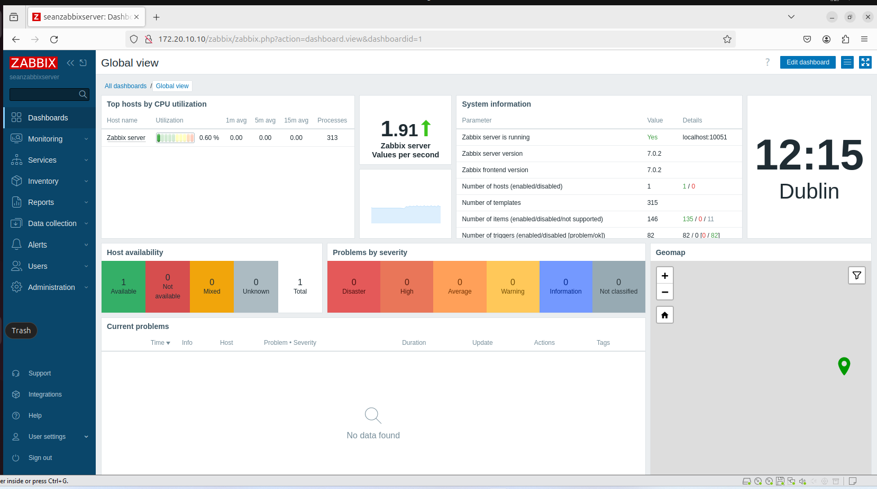

Customisation & Integration of Solution
Enhanced Security Measures:

- SSH Server:
  - Implemented key-based authentication to replace password authentication, significantly reducing the risk of brute-force attacks.
  - Configured the SSH server to listen on a non-standard port (e.g., 2222), which reduces exposure to automated attacks.
  - Restricted root login and limited SSH access to specific users to minimize security risks.
- Zabbix:
  - Customized user roles and permissions within Zabbix to ensure that only authorized personnel can access sensitive monitoring data.
  - Integrated Zabbix with a secure email server to send encrypted alerts and notifications to administrators.
Optimized Performance:
- DNS Server:
  - Configured DNS caching to reduce query response times and improve the speed of web browsing for users within the network.
  - Implemented DNS load balancing to distribute traffic evenly across multiple servers, ensuring high availability and reducing latency.
- Web Server:
  - Optimized Apache configuration by fine-tuning the KeepAliveTimeout and MaxClients settings to handle high traffic more efficiently.
  - Enabled Gzip compression to reduce the size of transferred data, resulting in faster page load times for users.
Ease of Administration:
- Zabbix:
  - Integrated automated scripts within Zabbix to streamline the process of adding new hosts and configuring monitoring templates.
  - Set up advanced triggers and custom alerts tailored to the specific needs of the organization, allowing for quicker response times in case of system issues.
Printer Management:
- Implemented centralized printer management, allowing administrators to easily add or remove printers from the network without having to visit each client machine.
- Configured automated email alerts to notify administrators of printer errors or low supplies, improving maintenance efficiency.
User and Group Management:
- Web Server:
  - Created user groups with specific permissions to manage different aspects of the web server, enhancing security by applying the principle of least privilege.
  - Set up automated user account creation and management processes, reducing administrative overhead and ensuring consistent access control.
Integration with Existing Systems:
- Zabbix:
  - Successfully integrated Zabbix with existing monitoring tools, enabling centralized monitoring of all network devices and services.
  - Configured Zabbix to pull in data from external databases and third-party APIs, providing a comprehensive view of system health and performance.

Final Report - Summary & Conclusion

Summary
From this assignment I have gained so much knowledge on a lot of things ranging from learning regular Linux commands to netplan configurations to DNS servers and so much more, I thoroughly enjoyed working on this project as I feel I have become a lot more efficient when it comes to my use of Linux commands knowing how to filter directories being able to edit configuration files and learning what ports to allow traffic into and what ports not to let traffic into through the use of firewall, In each task it was a challenge but through research into what I was working at and reading articles watching videos it helped me get such a good understanding for each task at the start it took me awhile to get my head around static Ips and DHCP and the whole network interface and how when both vm’s the server and the desktop use host only with a setup static IP address they can communicate with each other but not being connected to the internet and for internet usage you needed to have whatever vm you wanted to install anything on use DHCP and have the network adapter set to bridged, but as I said it was a great learning opportunity, I think I had most fun in the final part setting up the Network management system I chose Zabbix as that is what I use in my work experience in the company I work for so it was great to work with it in this assignment. I struggled most with the Print server I had it setup so I was able to add the printer but when I went to print off something it would be stuck in the sending and wasn’t confirmed that it was sent to my server. If there was thing I would do differently if I started again is my time management, I put on each task I put less time into the print server and that was the one I did poorest on so time management is what I would fix.

Conclusion
In this project, we successfully deployed a secure IT infrastructure, customized to meet the specific needs of our organization. By integrating advanced security measures across all services, such as implementing key-based SSH authentication and restricting access to critical servers, we have significantly enhanced the overall security posture. Our optimizations, particularly within the DNS and web servers, have led to improved system performance and responsiveness, ensuring a seamless user experience. The implementation of Zabbix as our network monitoring solution has not only provided real-time insights into system health but has also allowed for proactive management through custom alerts and automated responses. This has greatly reduced downtime and improved operational efficiency. Looking ahead, there is potential to further enhance our infrastructure by exploring automation tools for routine maintenance tasks and integrating more advanced analytics into our monitoring systems. Overall, this project has laid a strong foundation for a secure, efficient, and scalable IT environment, positioning us well for future growth and challenges. On a more personal note If given more time for this assignment I would have implemented such features like role based access control across all services on a granular level, maybe automated backups in case of a system failure also in relation to the video and doc I would have gone in more depth of the implementation of the configuration of each service if I had recorded each service after I had implemented them rather than doing all of them at the end.

References
https://www.linkedin.com/pulse/how-install-zabbix-monitoring-ubuntu-server-sana-masood-fbubf
https://help.ubuntu.com/community/BIND9ServerHowto
https://help.ubuntu.com/community/isc-dhcp-server
https://ubuntu.com/server/docs/install-and-configure-a-cups-print-server
https://reintech.io/blog/setting-up-mail-server-dovecot-ubuntu
https://ubuntu.com/server/docs/install-and-configure-postfix
https://www.digitalocean.com/community/tutorials/how-to-install-and-configure-postfix-as-a-send-only-smtp-server-on-ubuntu-20-04
https://www.digitalocean.com/community/tutorials/initial-server-setup-with-ubuntu-20-04
https://www.zabbix.com/documentation/current/en/manual/installation/install
https://www.linkedin.com/pulse/how-install-zabbix-monitoring-ubuntu-server-sana-masood-fbubf
https://www.zabbix.com/download_sources
https://www.cherryservers.com/blog/how-to-install-and-configure-a-private-bind-dns-server-on-ubuntu-22-04
https://avahi.org/
https://help.ubuntu.com/community/Printers

